**CUSTOMER-INFO-SERVICE:**

1. Post personal customer without errors:

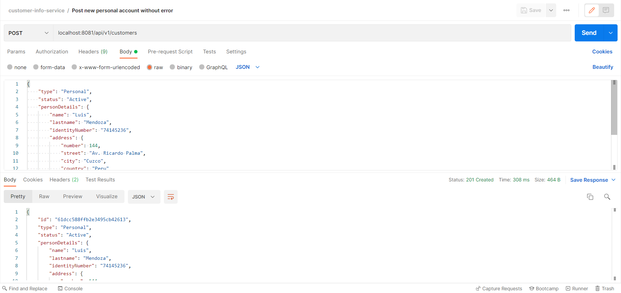

1. Post new personal customer with error: duplicated identityNumber field

As it can be seen, the customer to create have the same identityNumber as the user created in operation 1. For that reason, post operation returns a 409-conflict error.

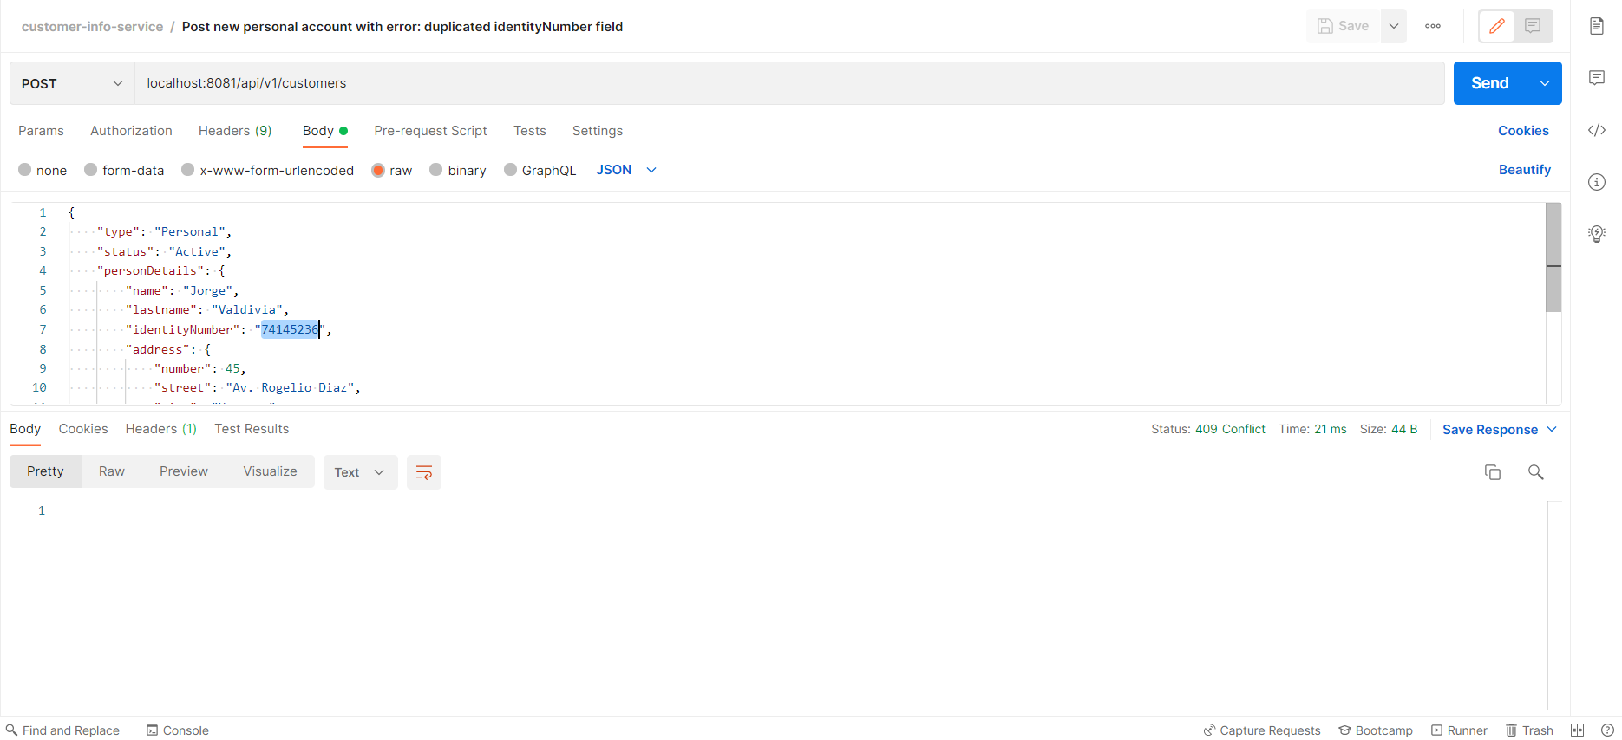

In the application console we can see the following logs:

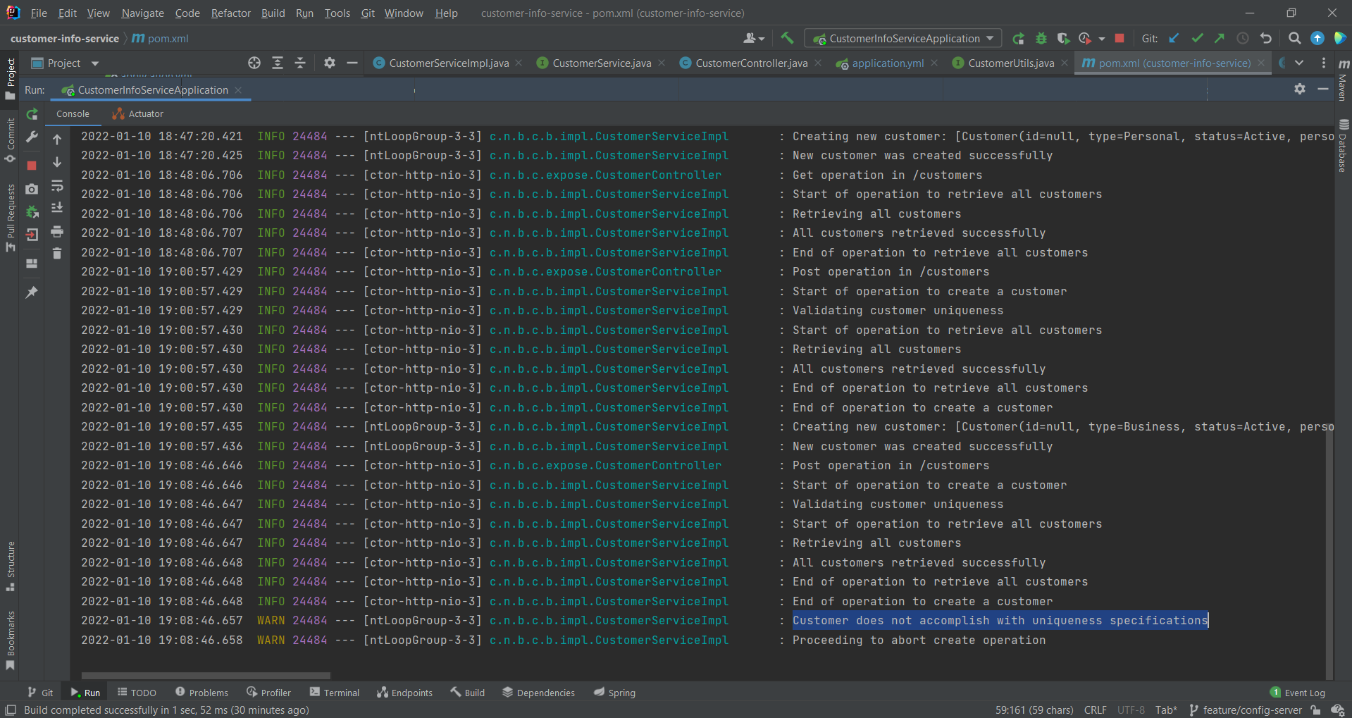

1. Post business customer without errors:

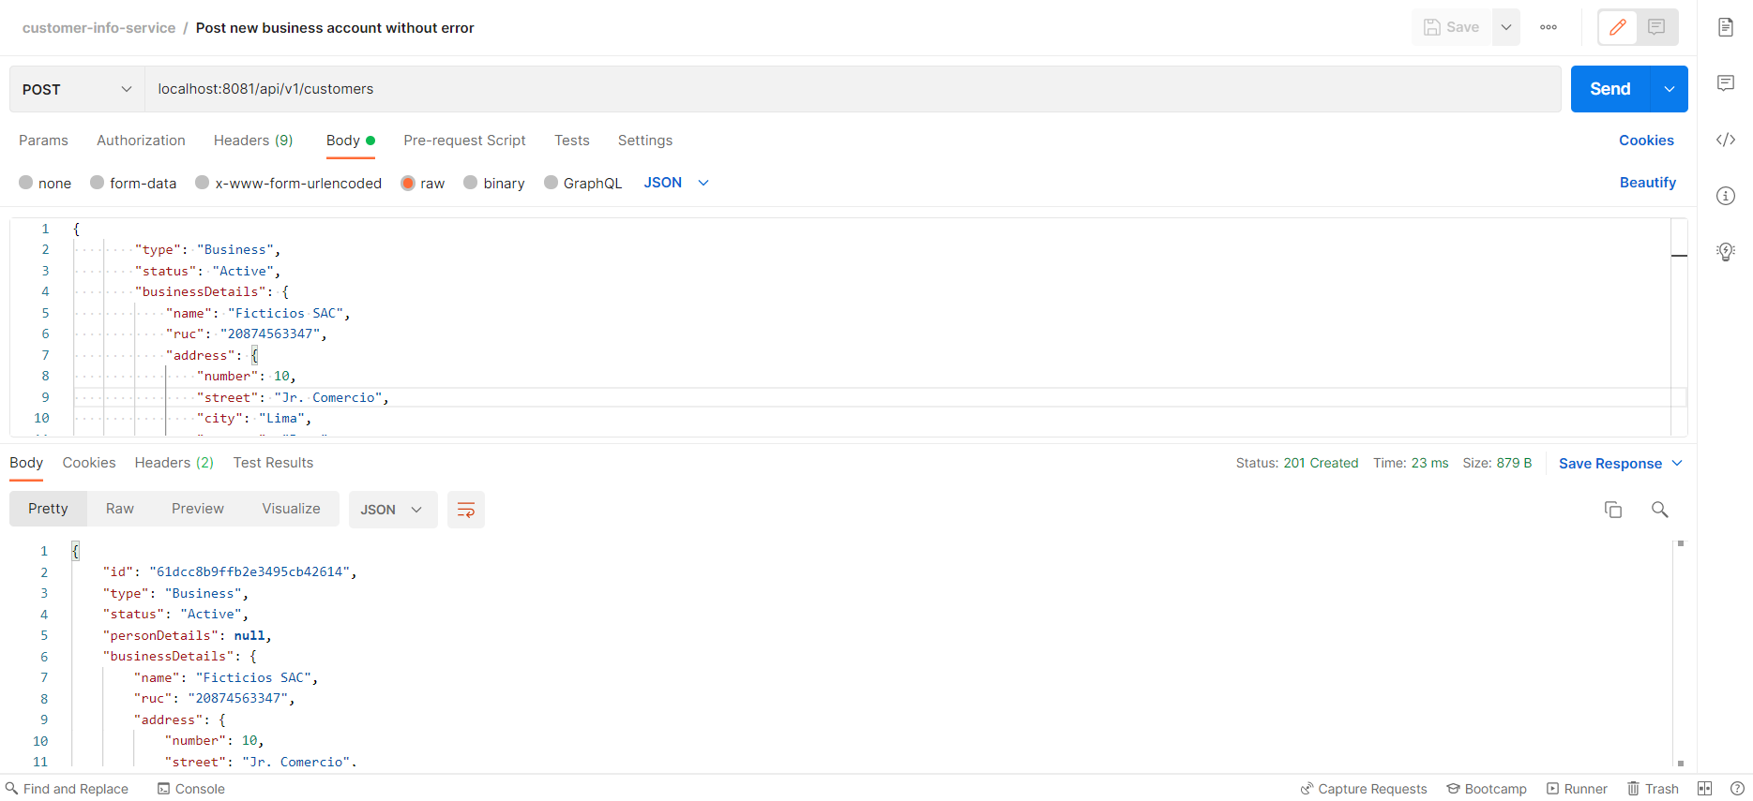

1. Post new business customer with error: duplicated name field:

As it can be seen, the customer to create have the same name as the customer created in operation 3. For that reason, post operation returns a 409-conflict error.

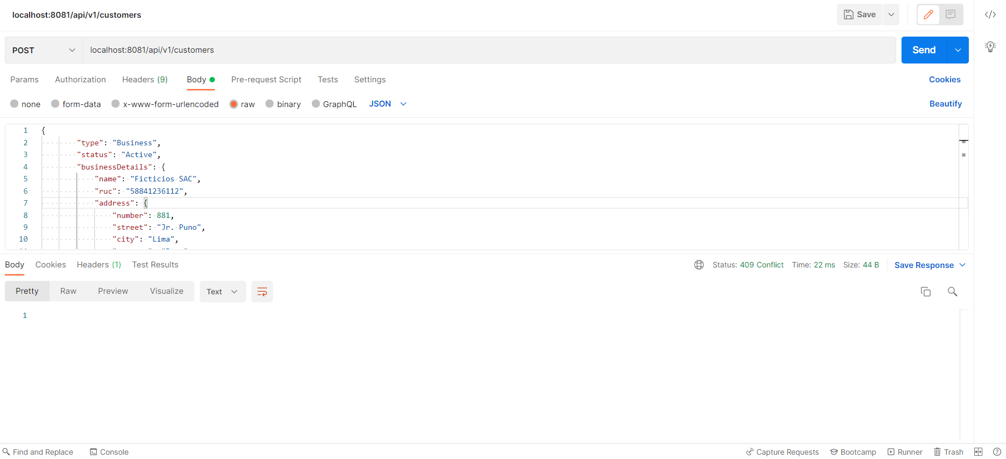

In console, we can see the following logs:

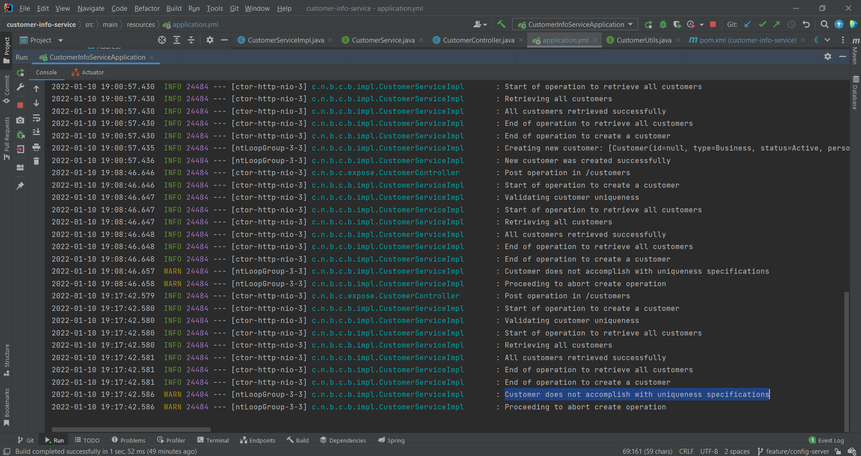

1. Post new business customer with error: duplicated ruc field:

As it can be seen, the customer to create have the same RUC as the customer created in operation 3. For that reason, post operation returns a 409-conflict error.

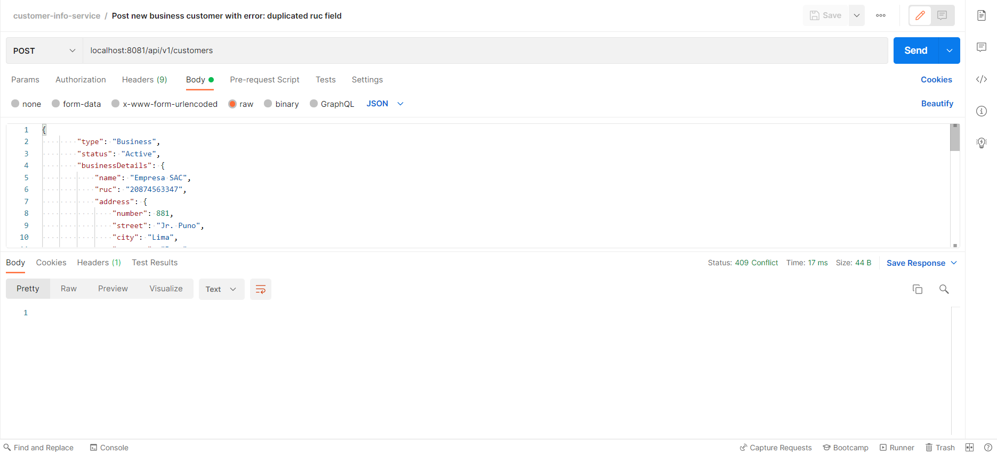

In console, we can see the following logs:

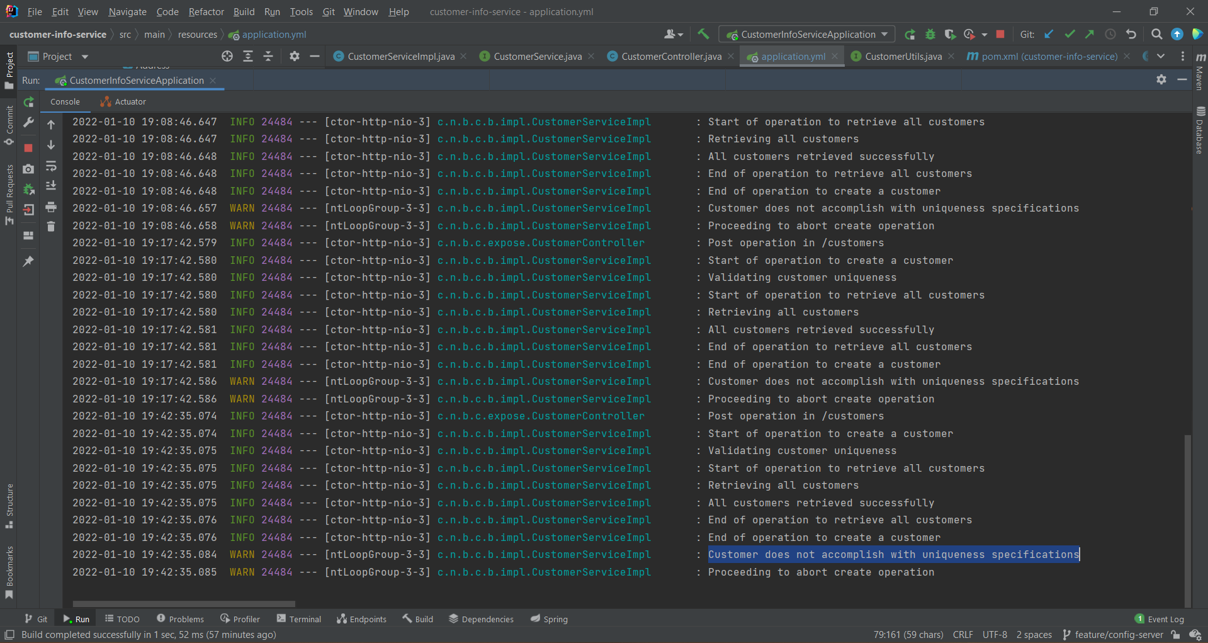

1. Get all customers:

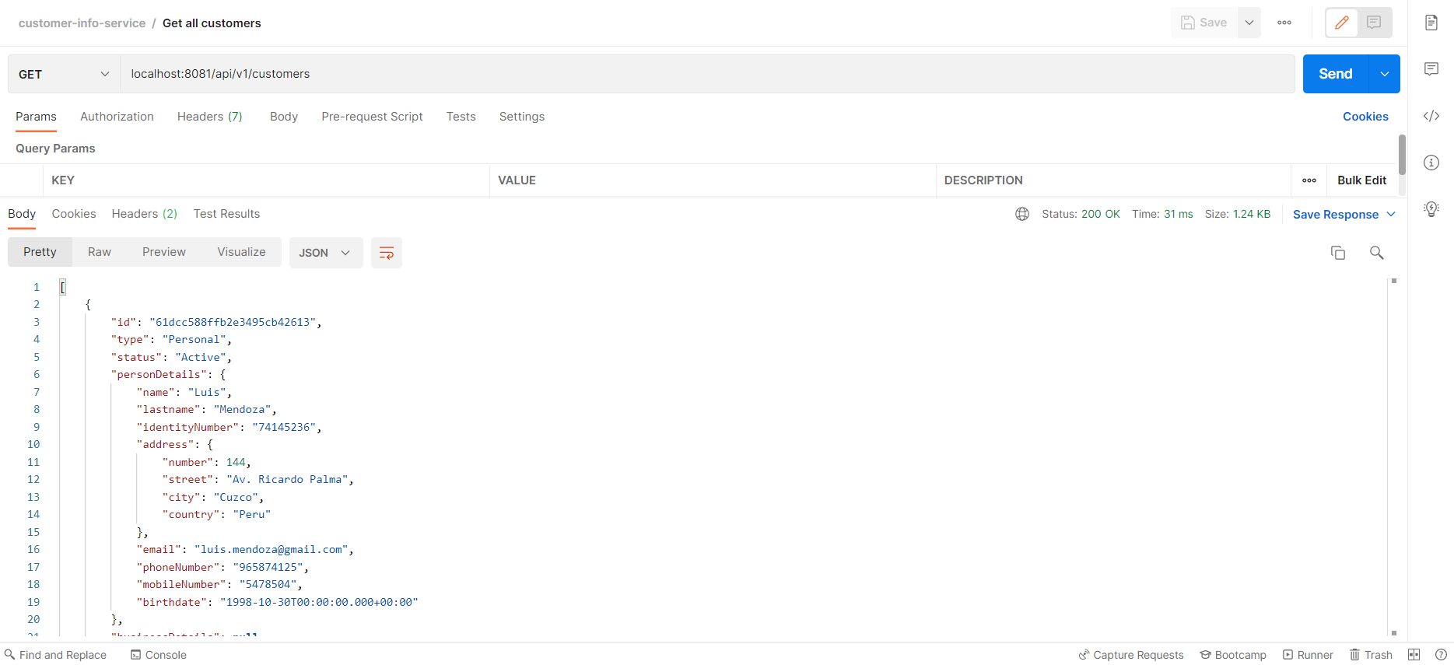

1. Get customer by id:

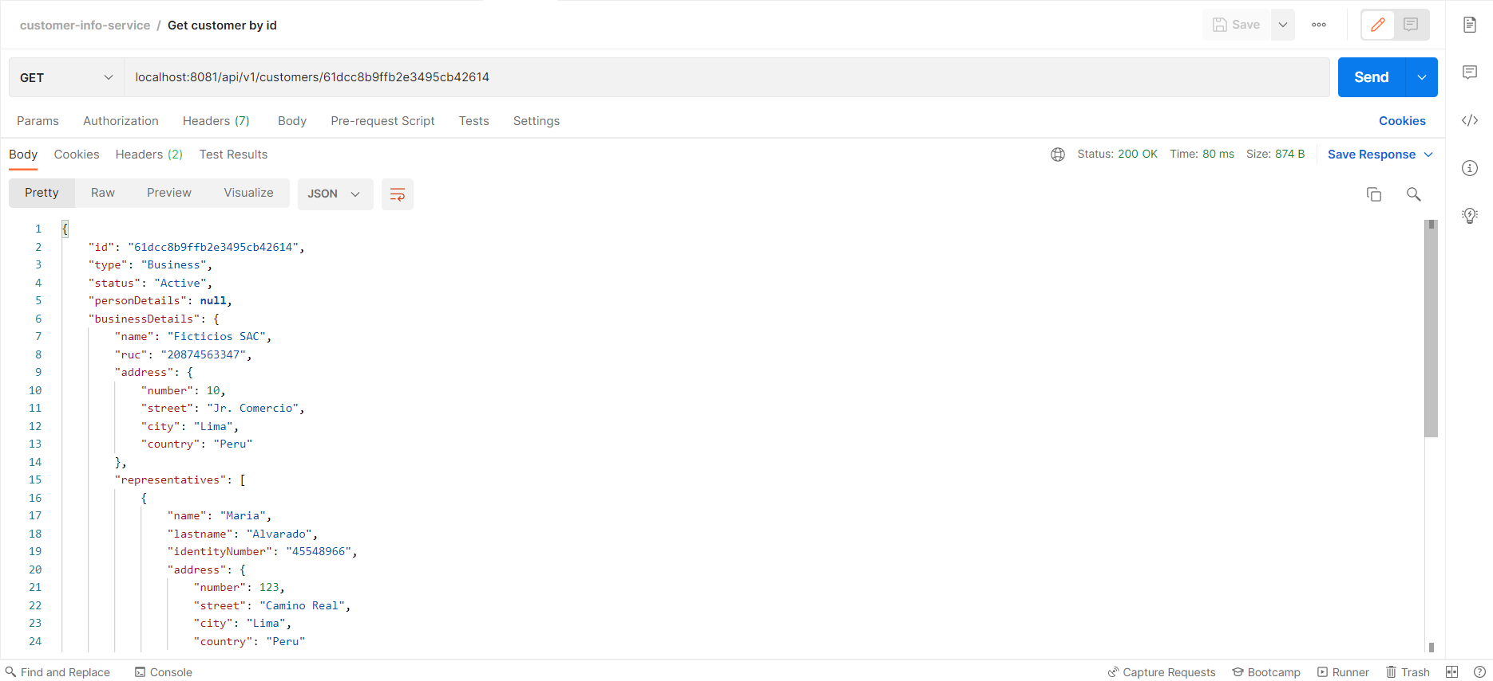

1. Put customer without error:

Updated status and name from the business account created in operation 3.

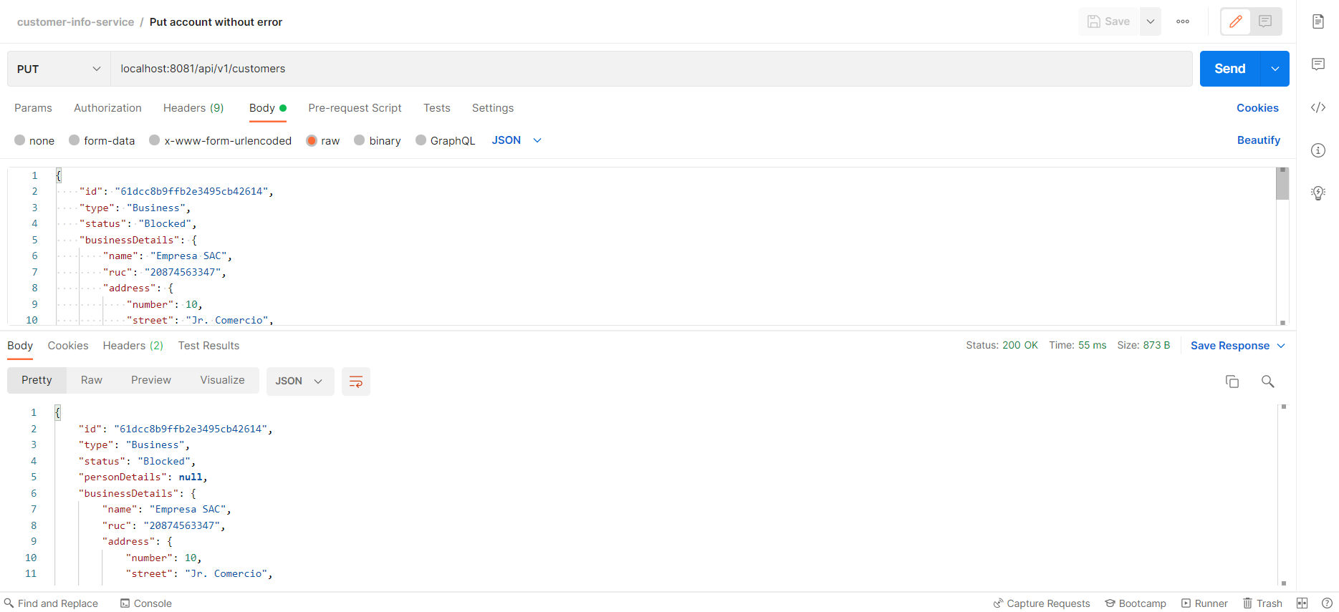

This operation also validates name and ruc uniqueness for business accounts and identityNumber uniqueness for personal accounts.

1. Put customer with error: customer not found:

Customer was not found, so a 404-not-found status was returned.

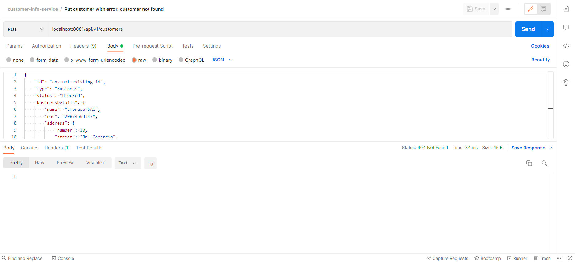

In console, we can see the following logs:

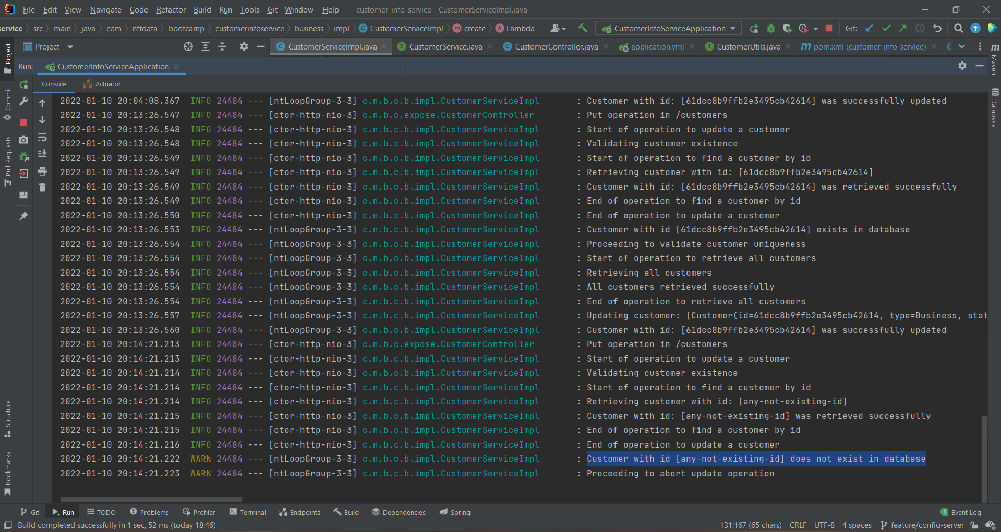

1. Delete customer without error:

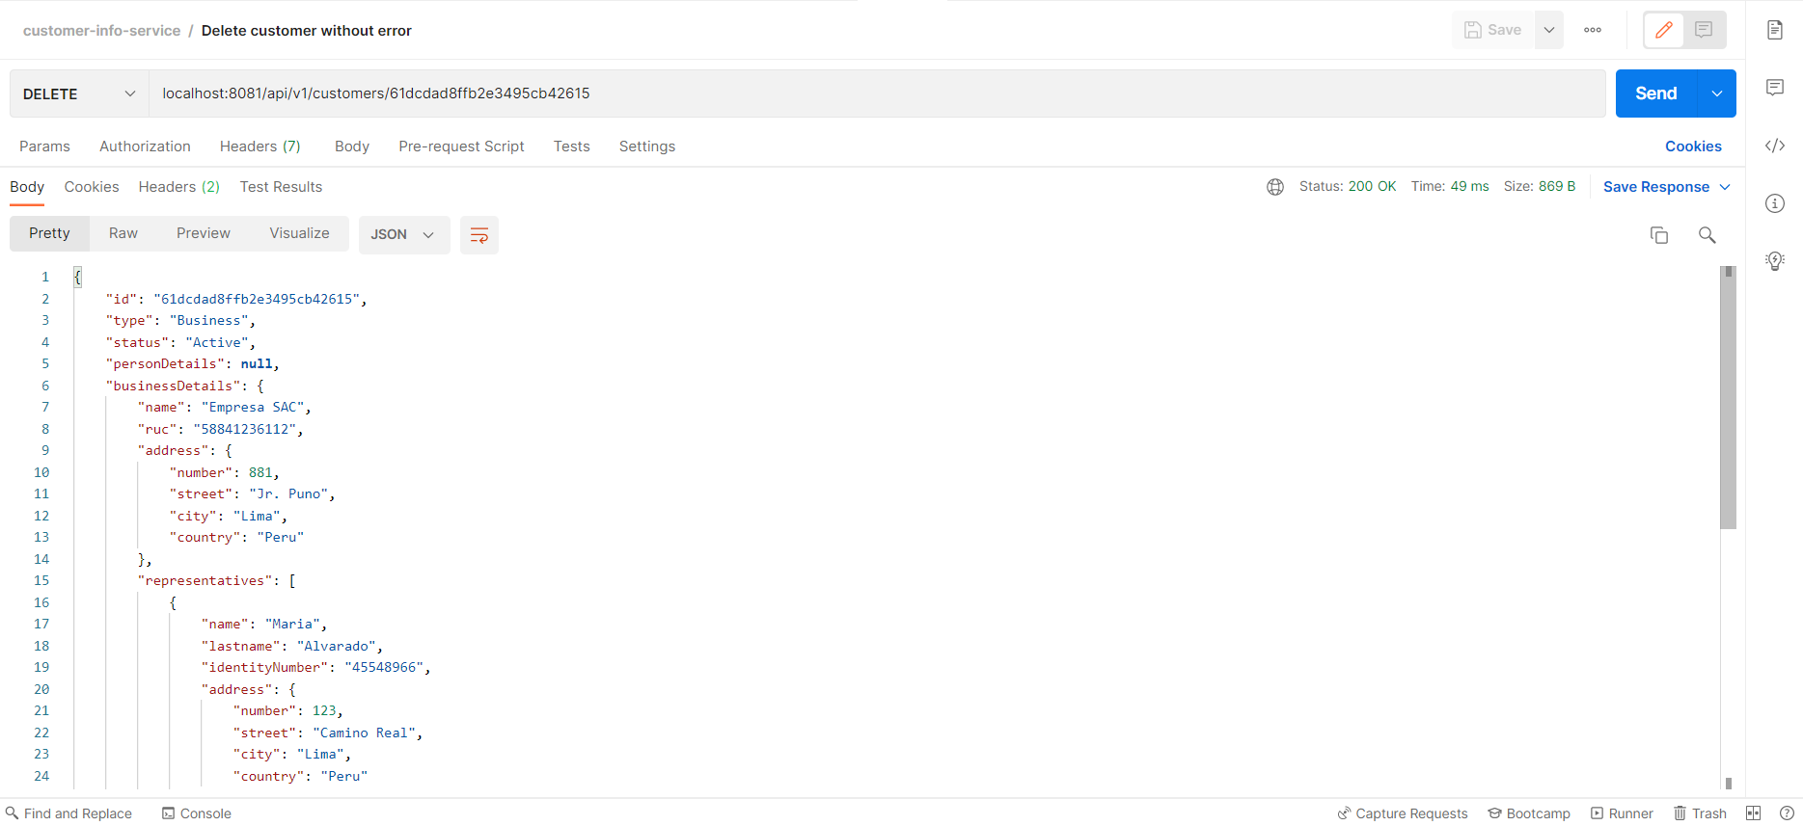

1. Delete customer with error: customer not found:

Customer was not found, so a 404-not-found status was returned.

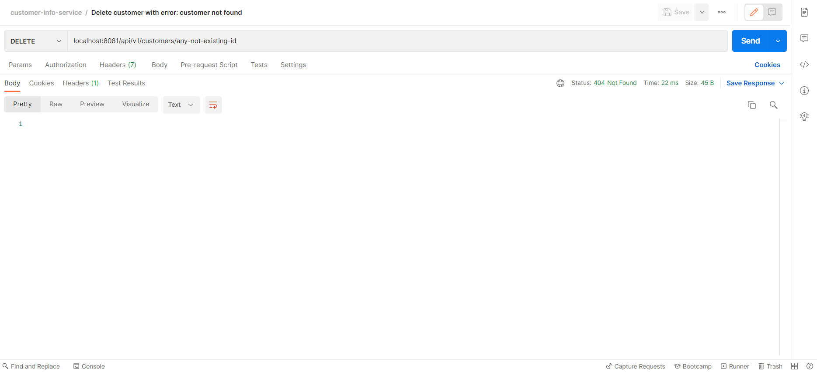

**PASSIVE-OPERATIONS-SERVICE:**

1. Post new personal account without error:

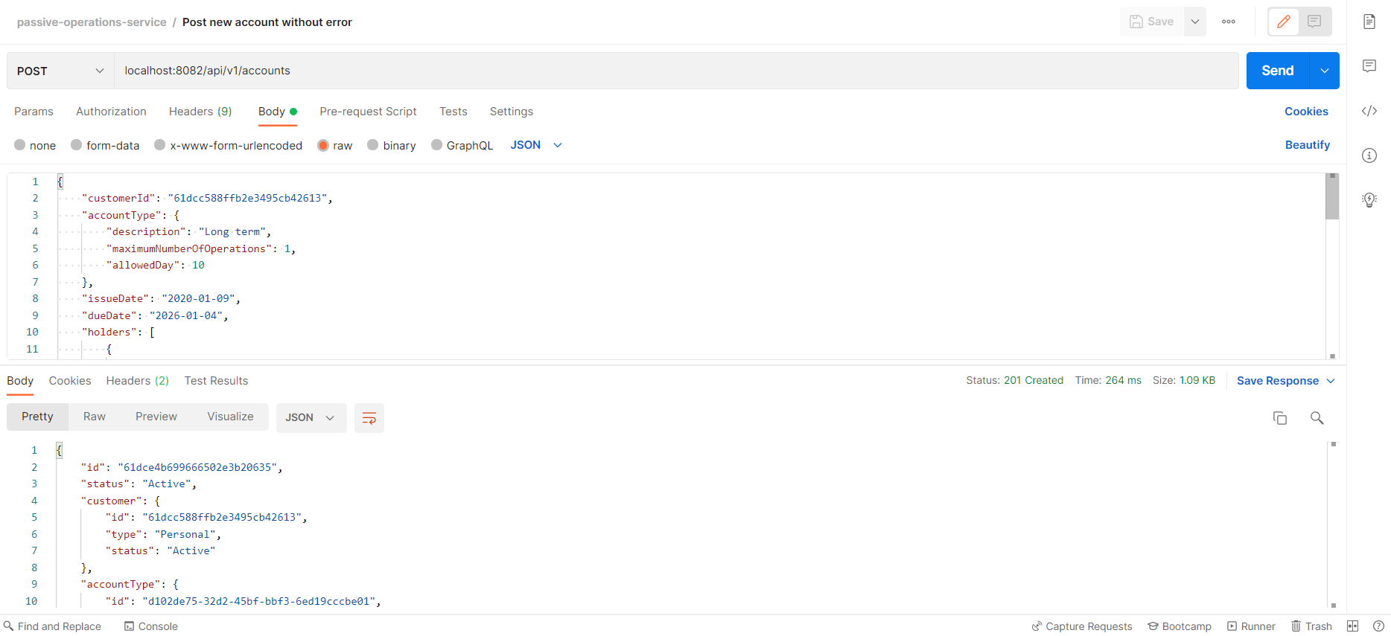

1. Post new personal account with error: personal customers can only have one account:

When attempting to create another account for the same customerId of operation 1, we get a 500-internal-server-error response, because personal customers can only have one account.

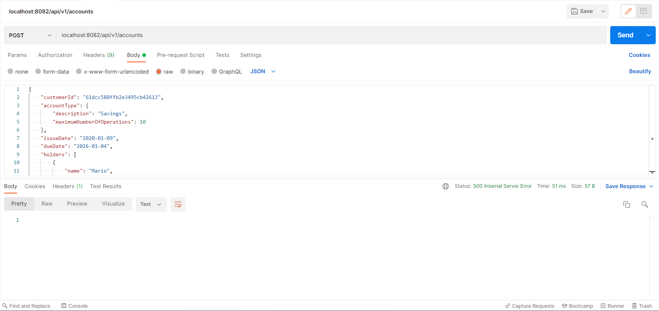

In console, we see the following logs:

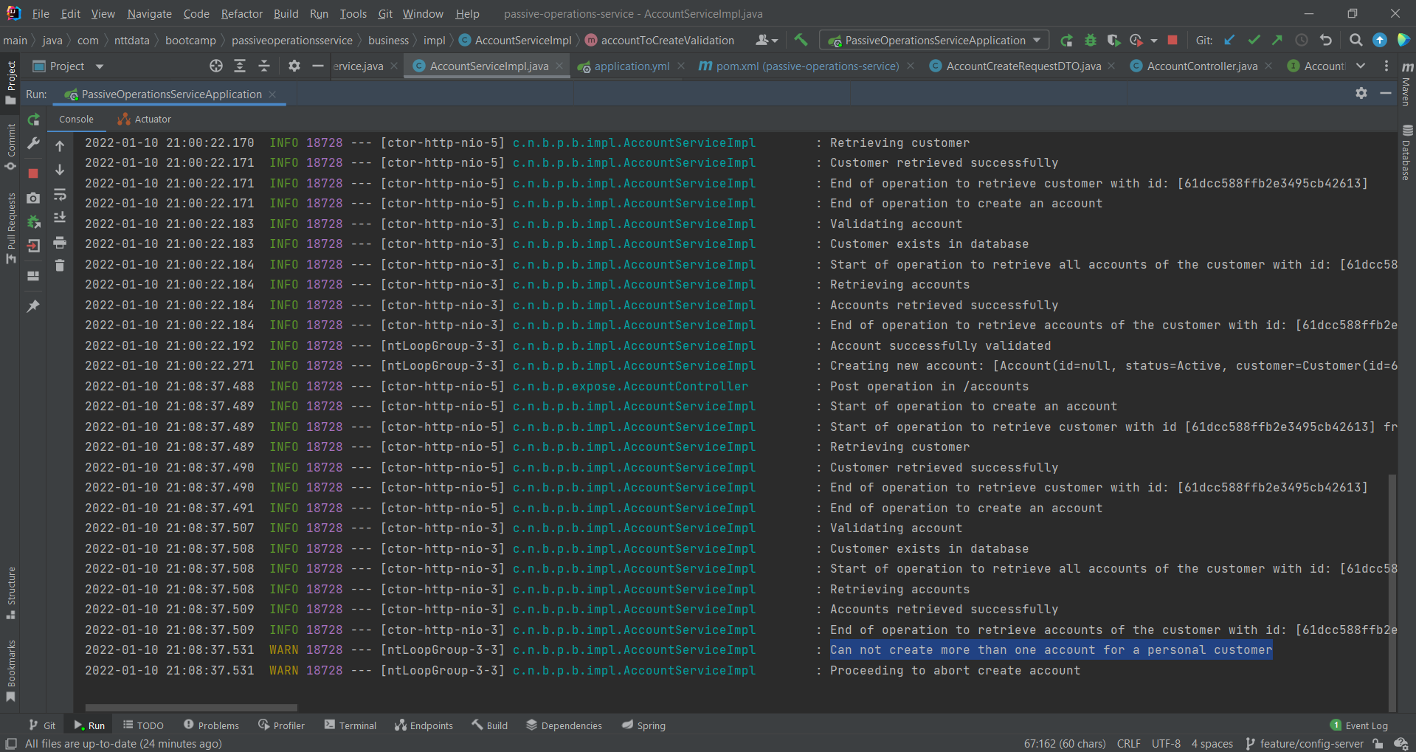

1. Post new business account without error:

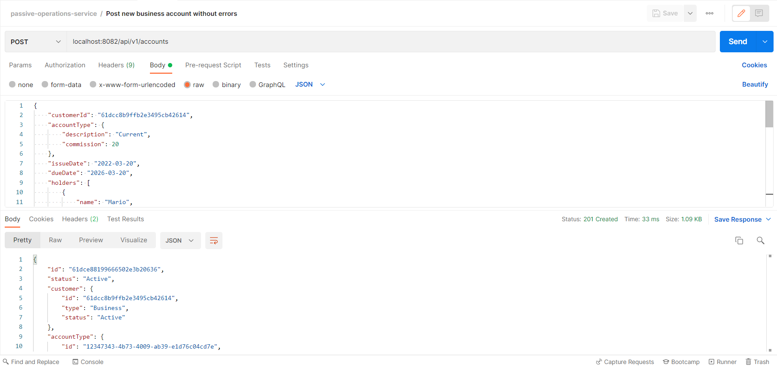

1. Post new business account with error: business customers can only have current accounts:

When attempting to create a non-current account for a business customer, we get a 500-internal-server-error response, because business customers can only have current accounts.

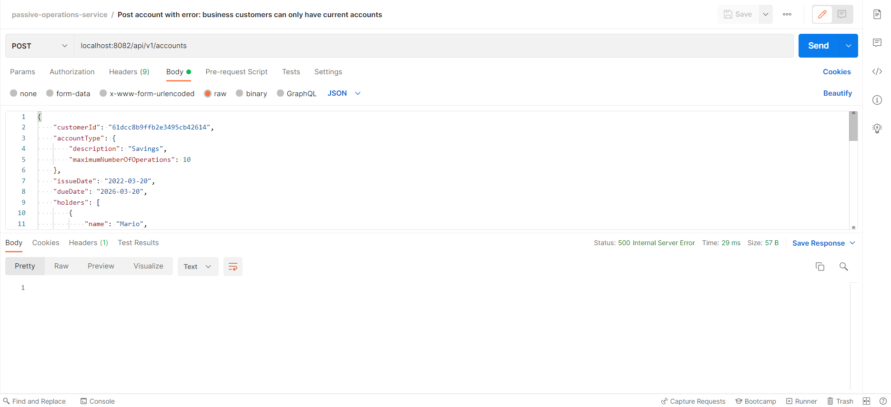

In console, we see the following logs:

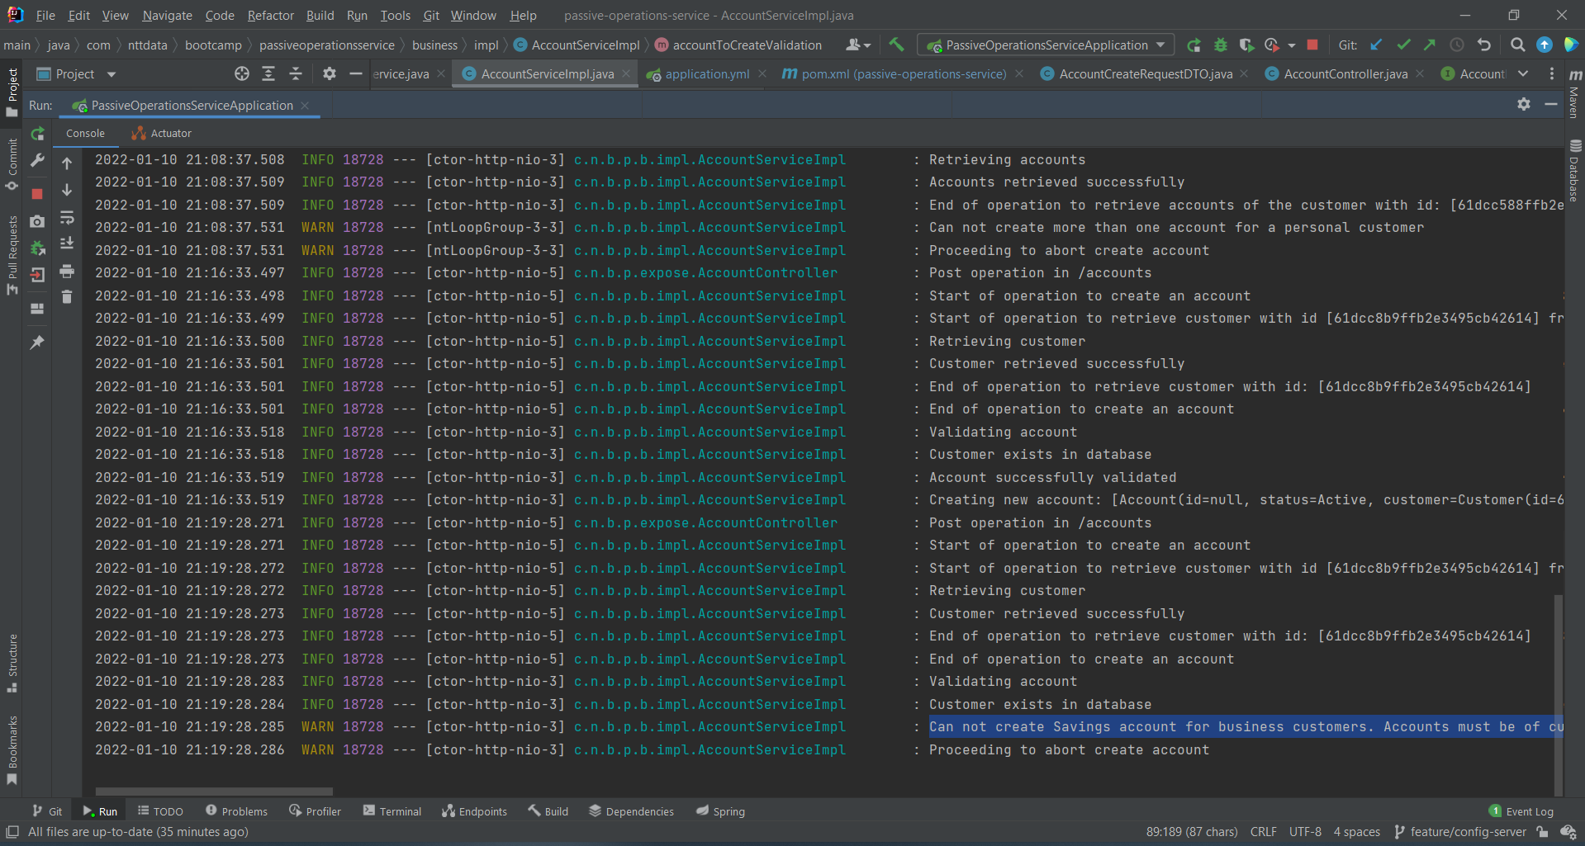

1. Post new account with error: customers cannot create accounts when they have locked status:

When attempting to create an account for a blocked customer, we get a 423-locked response.

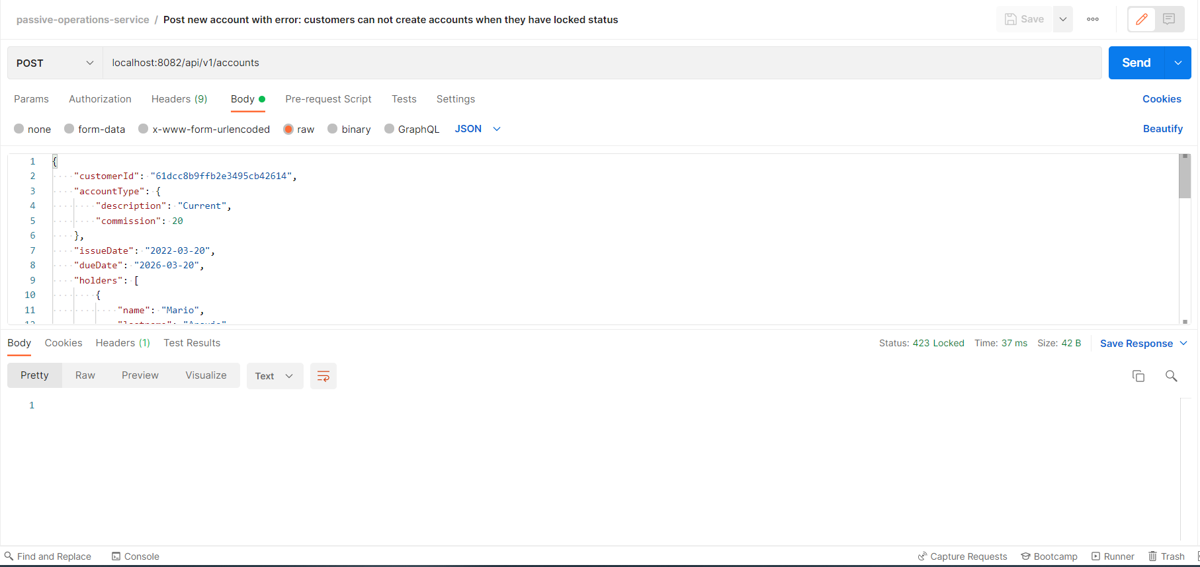

In console, we get the following logs:

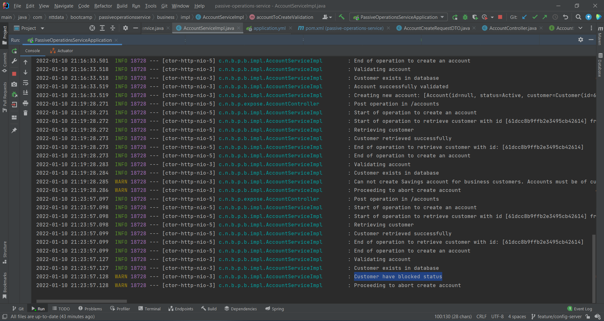

1. Post new account with error: account does not have holders:

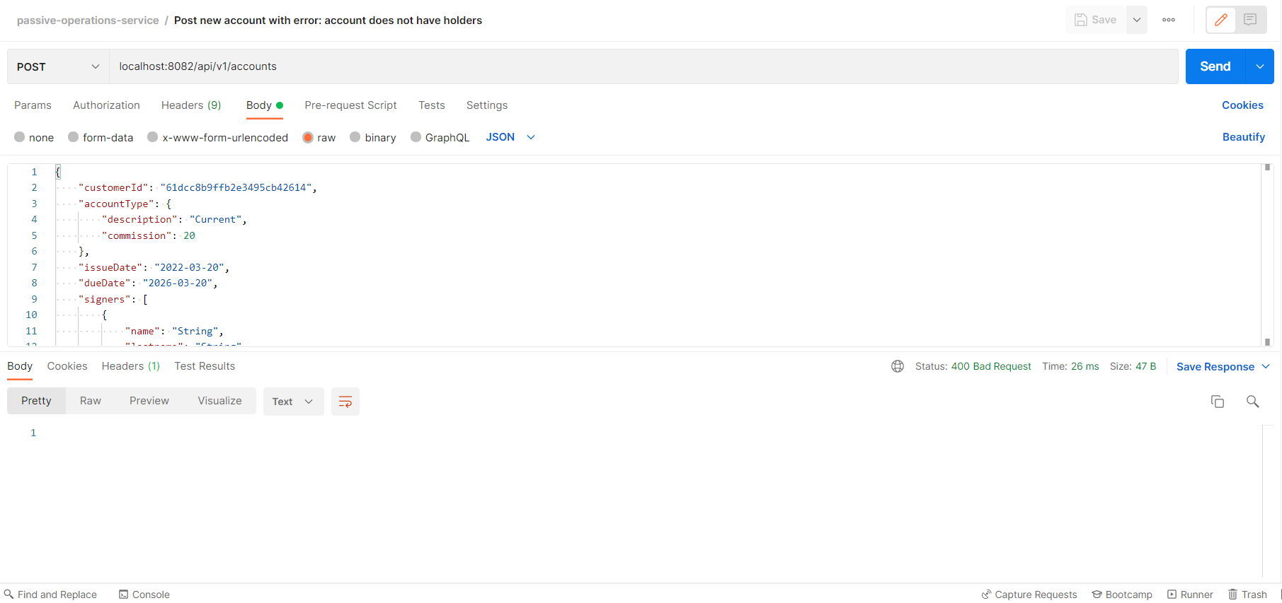

In console, we see the following logs:

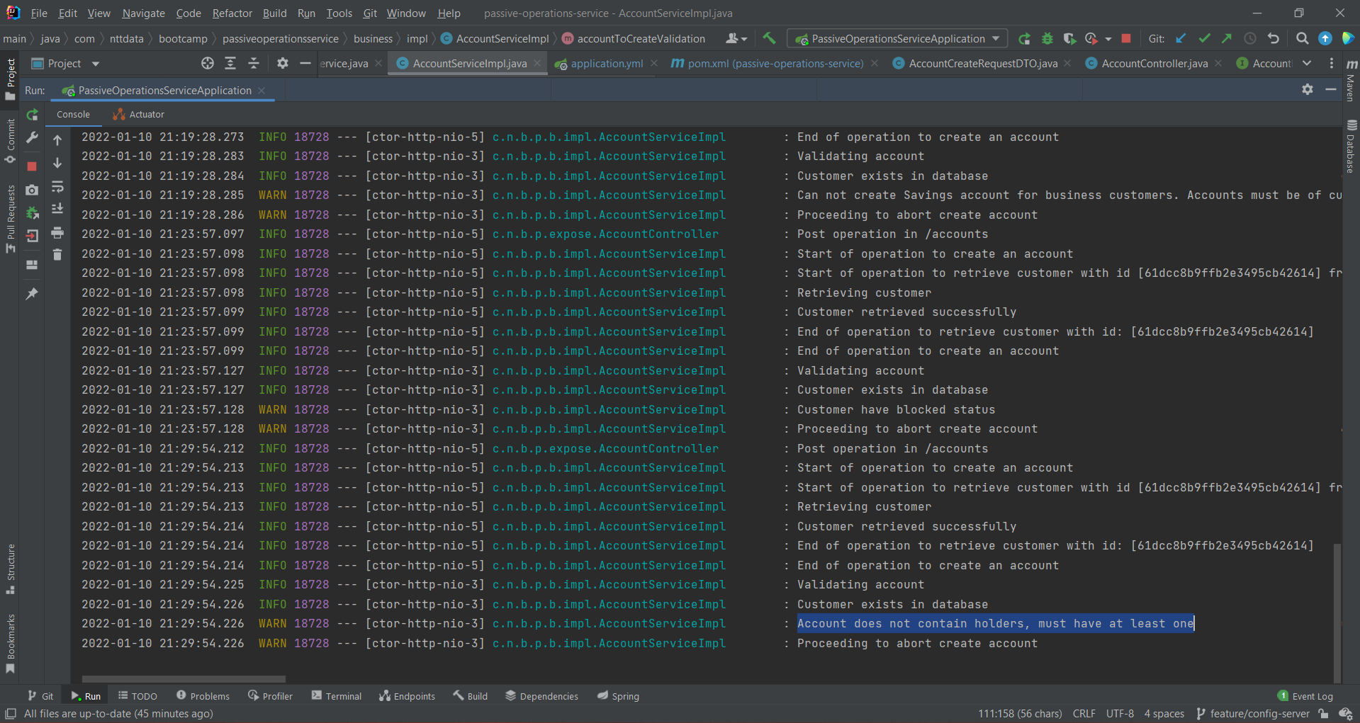

1. Get all accounts:

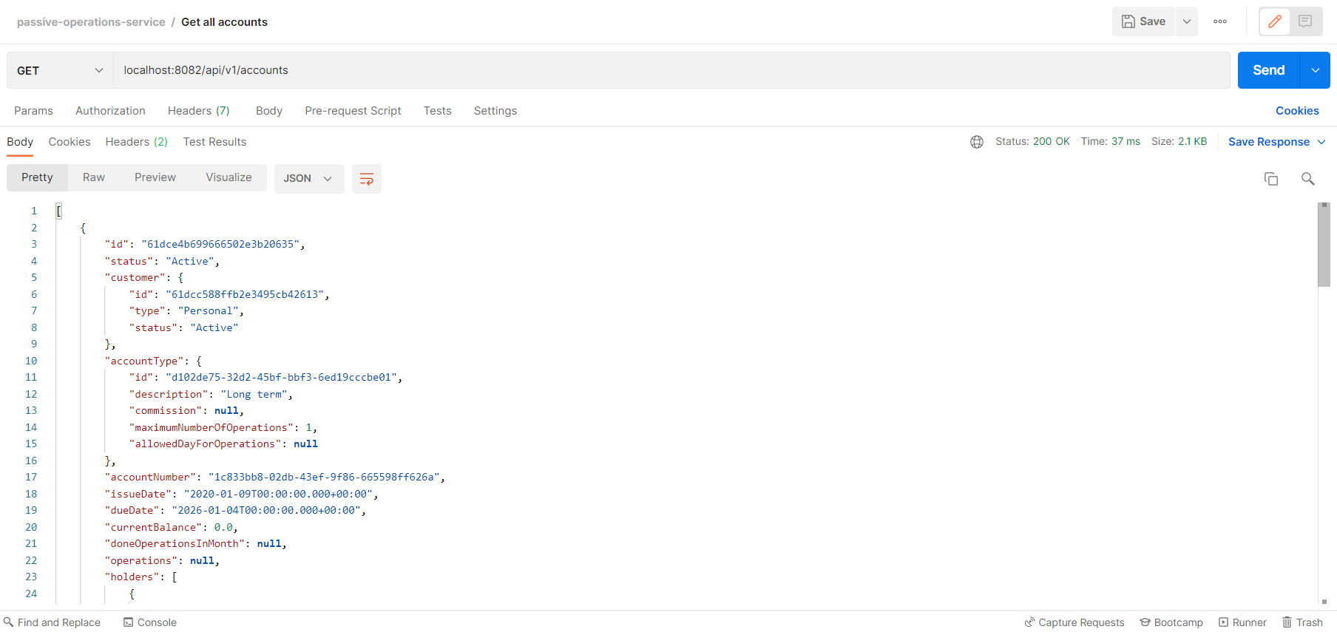

1. Get account by id:

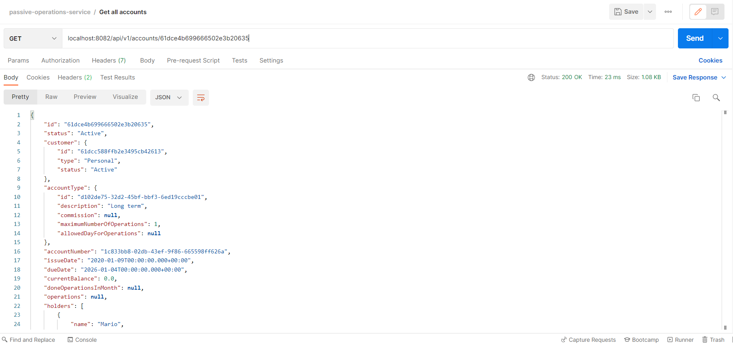

1. Put account without error:

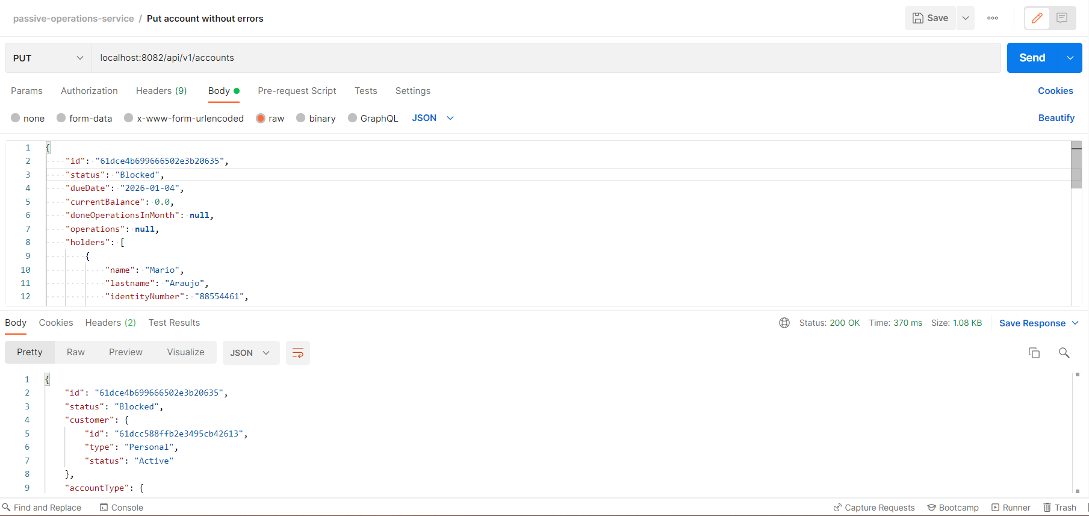

1. Put account with error: not found account:

Account was not found, so a 404-not-found status was returned.

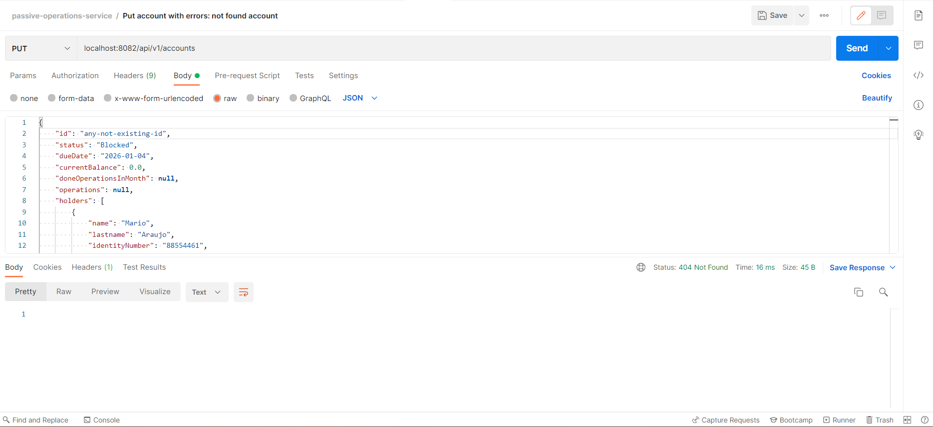

1. Put account with error: account does not have holders:

Account does not contain holders, it must contain at least one, so we get a 400-bad-request status.

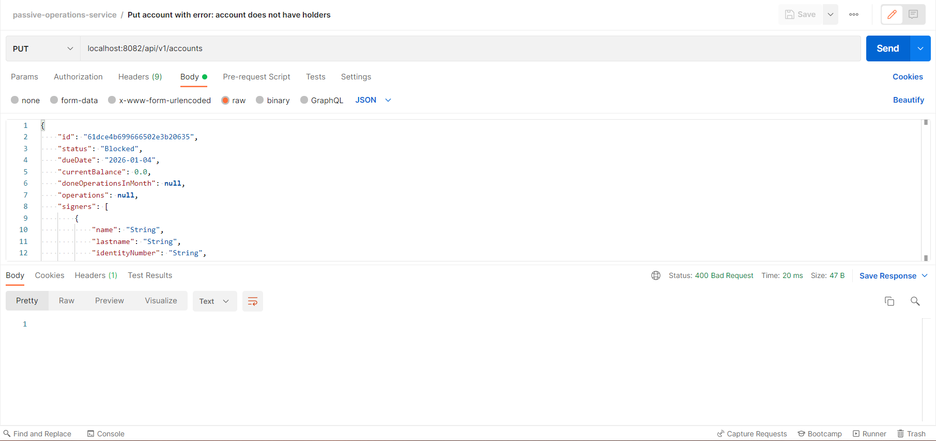

In console, we see the following logs:

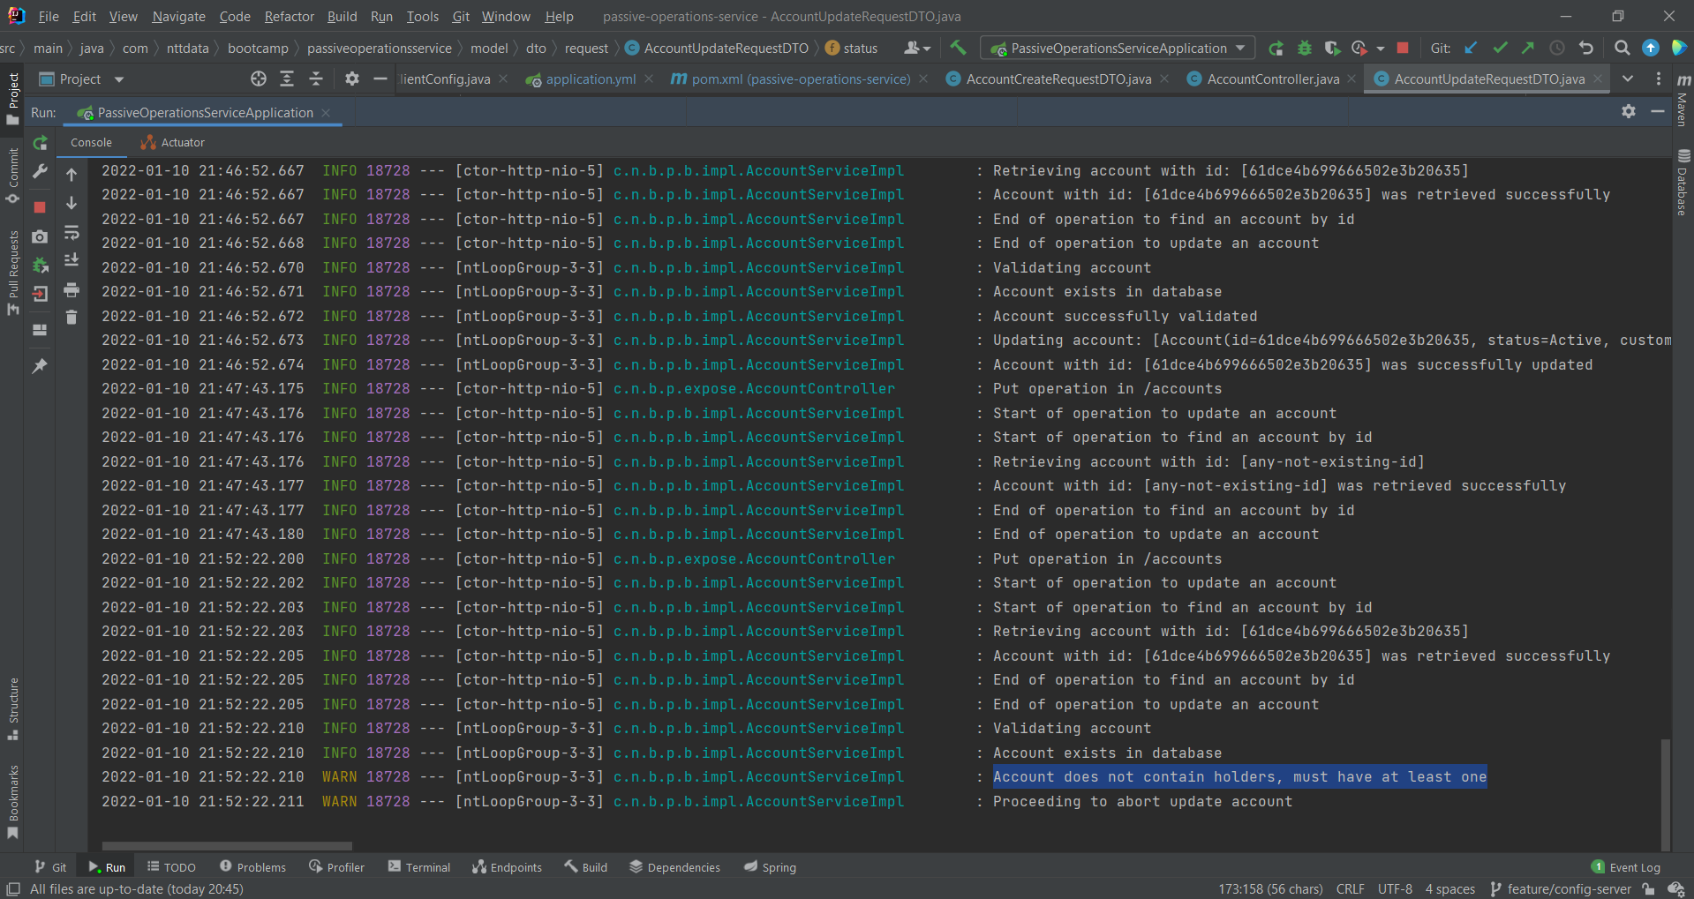

1. Delete account without error:

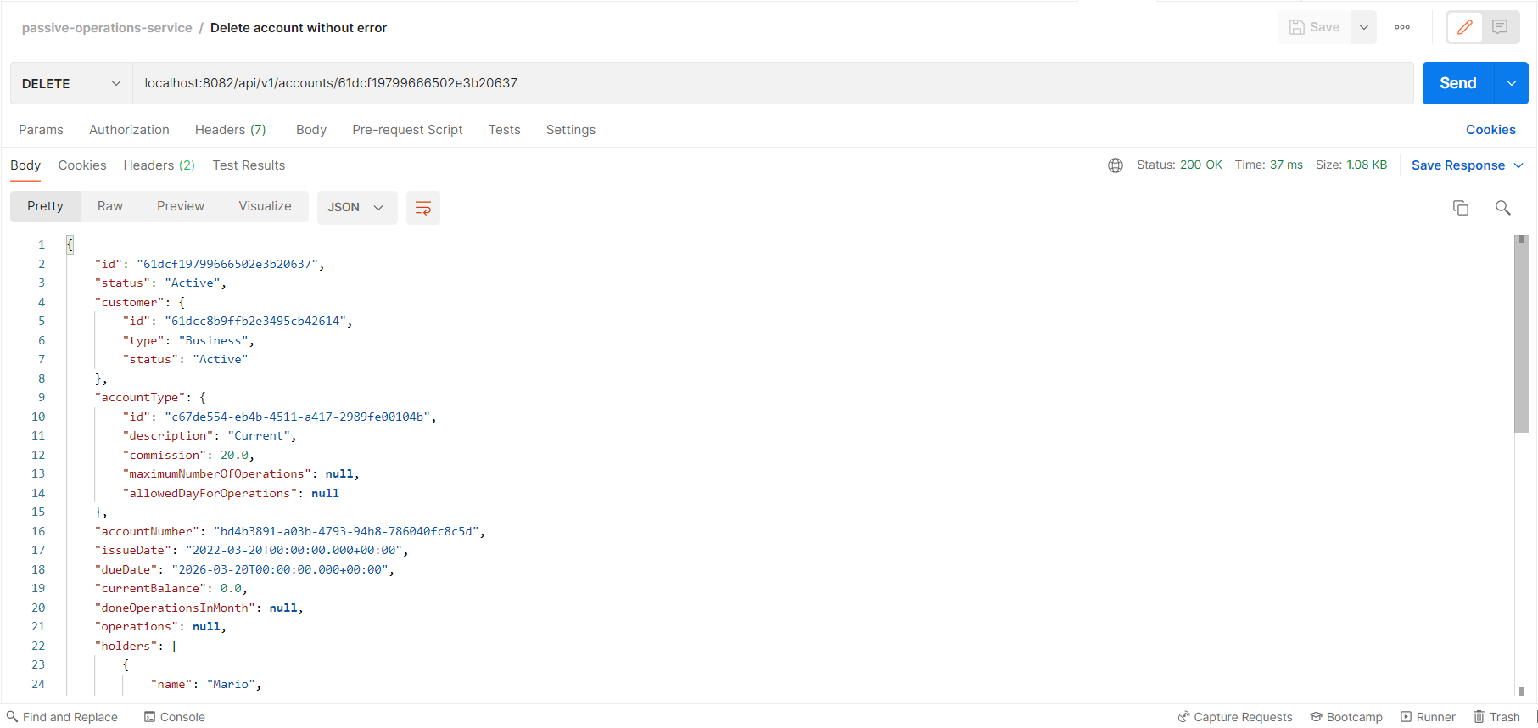

1. Delete account with error: account not found:

Account was not found, so a 404-not-found status was returned.

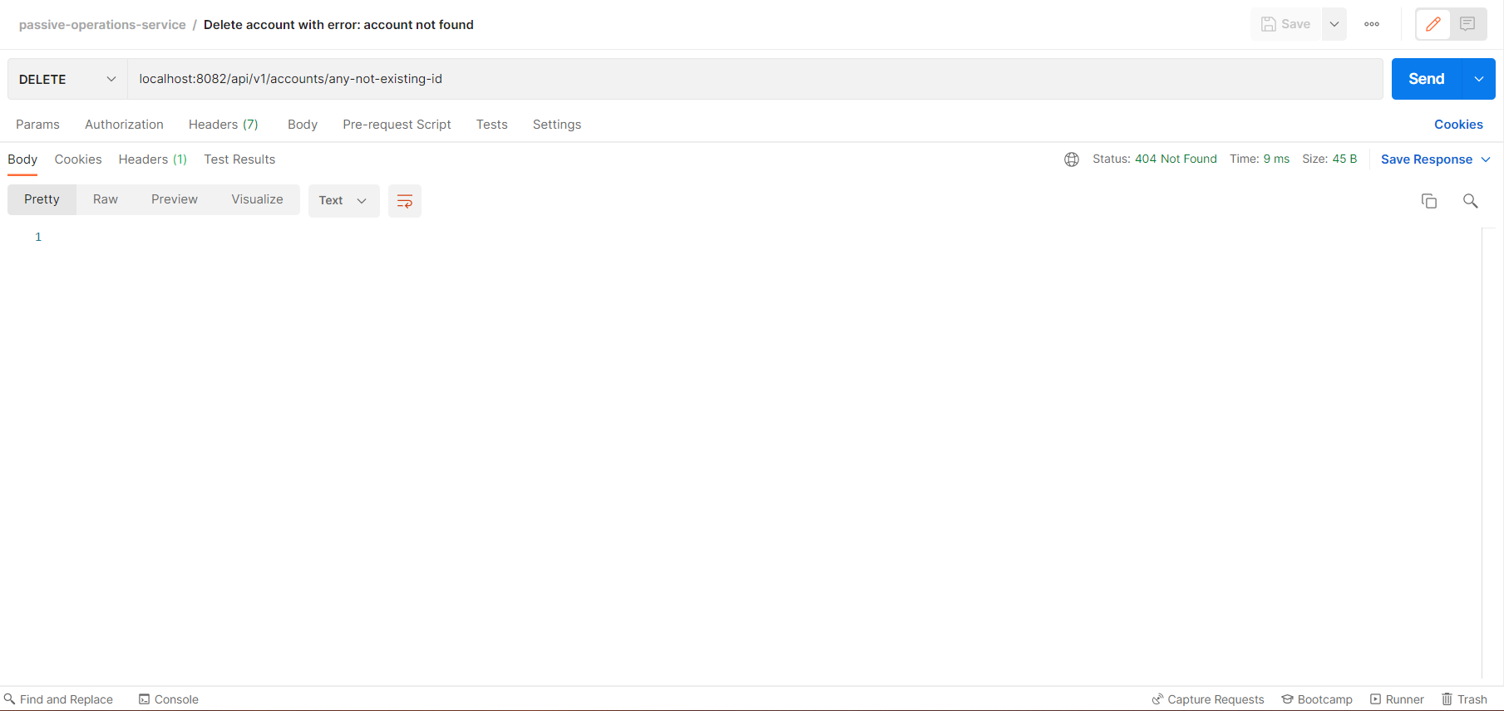

1. Get accounts by customer id:

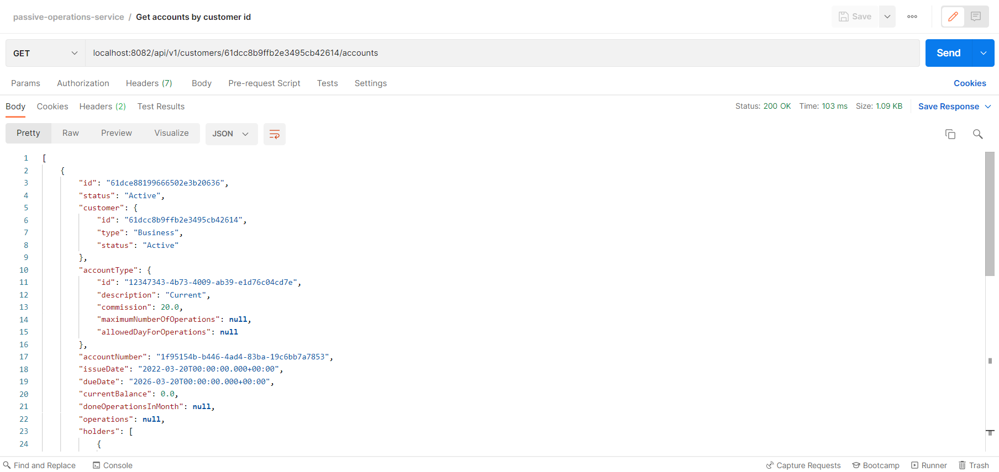

1. Post do operation without error:

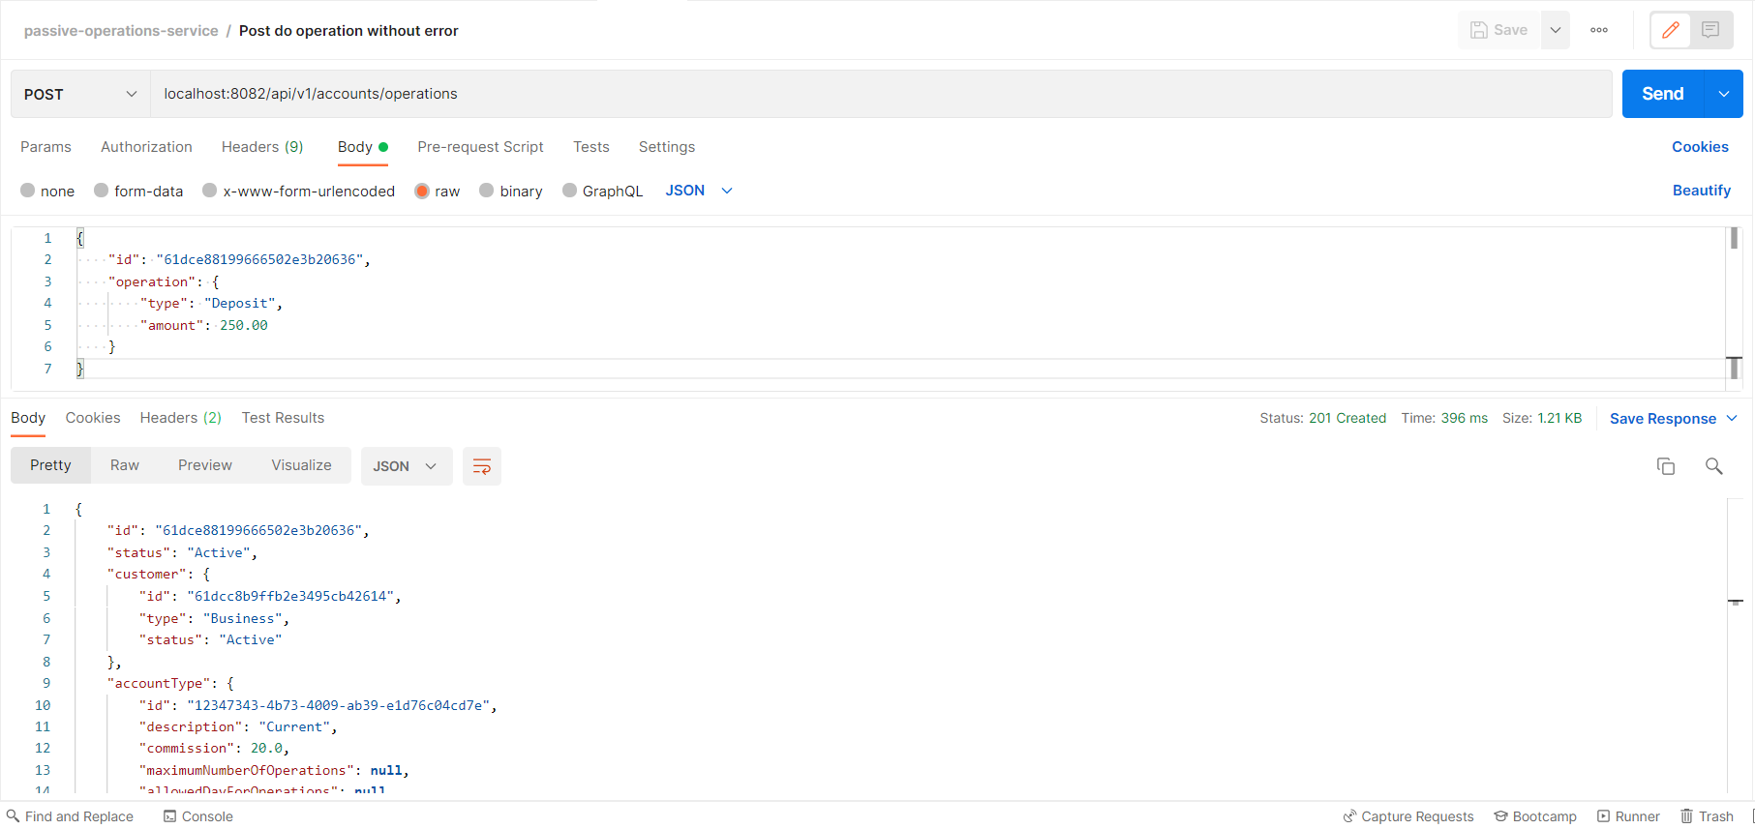

1. Post do operation with error: account has insufficient funds:

A customer cannot withdraw an amount greater than its current balance. If it attempts to do so, then an status 400-bad-request is returned.

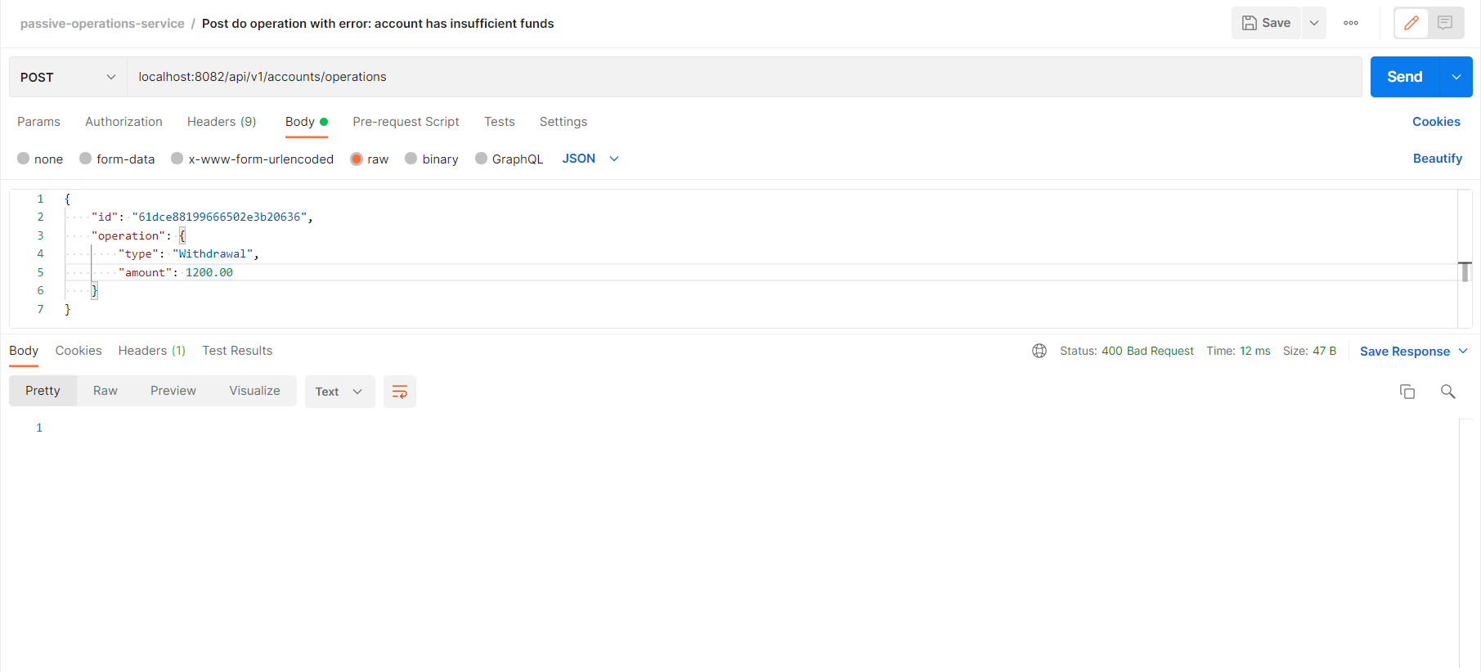

In console, we can see the following logs:

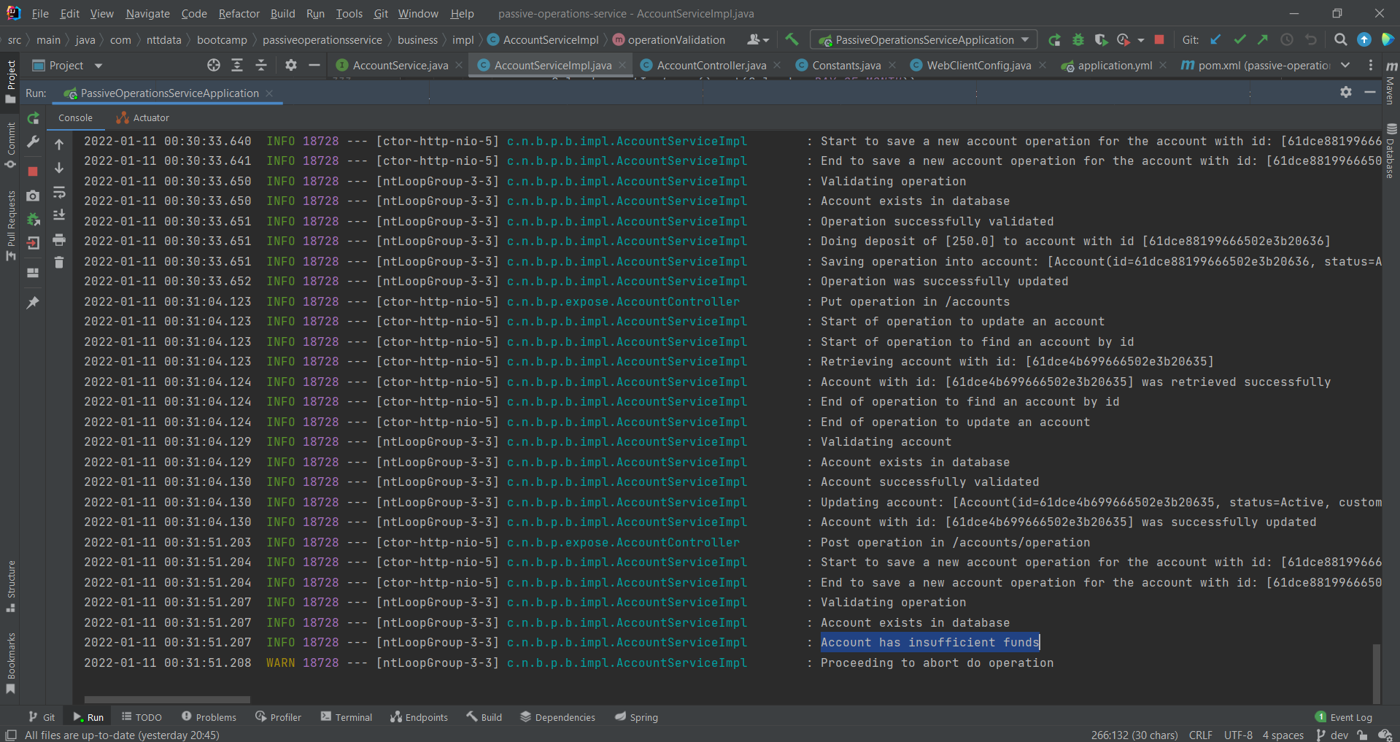

1. Post do operation with error: allowed day for operations does not match current day of the month:

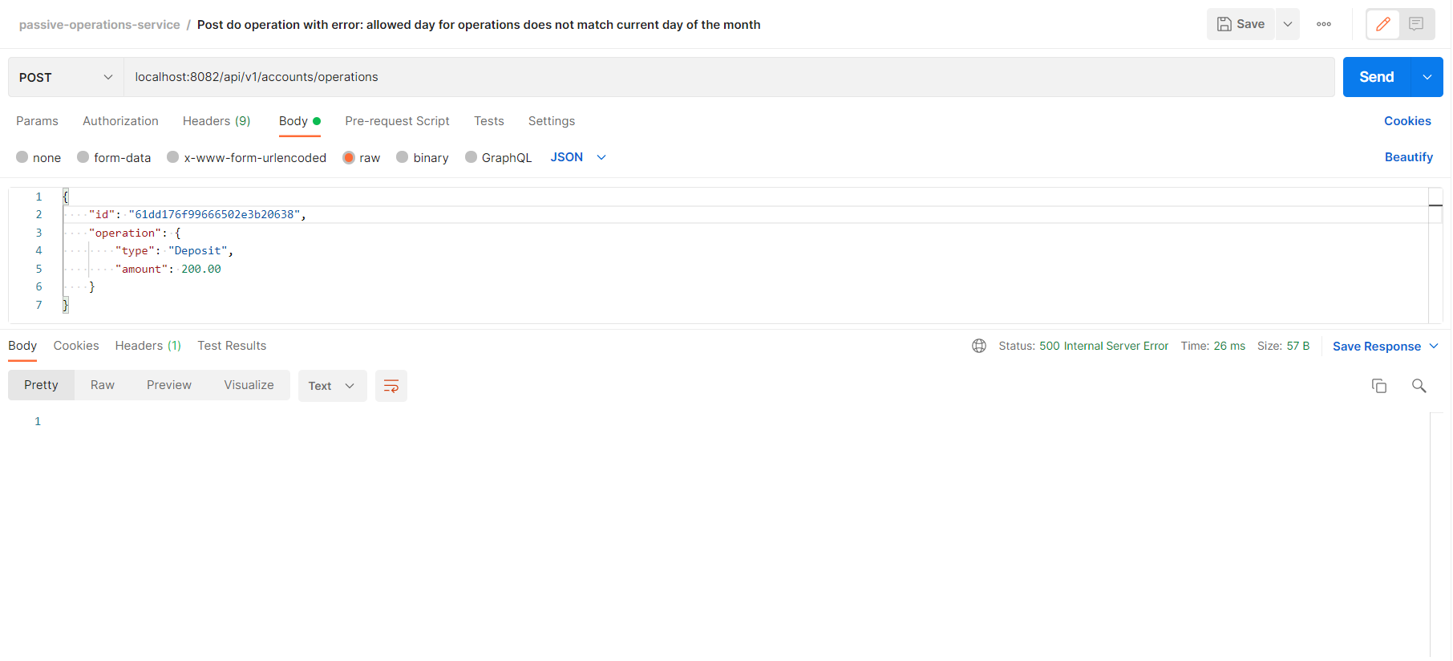

In console, we can see the following logs:

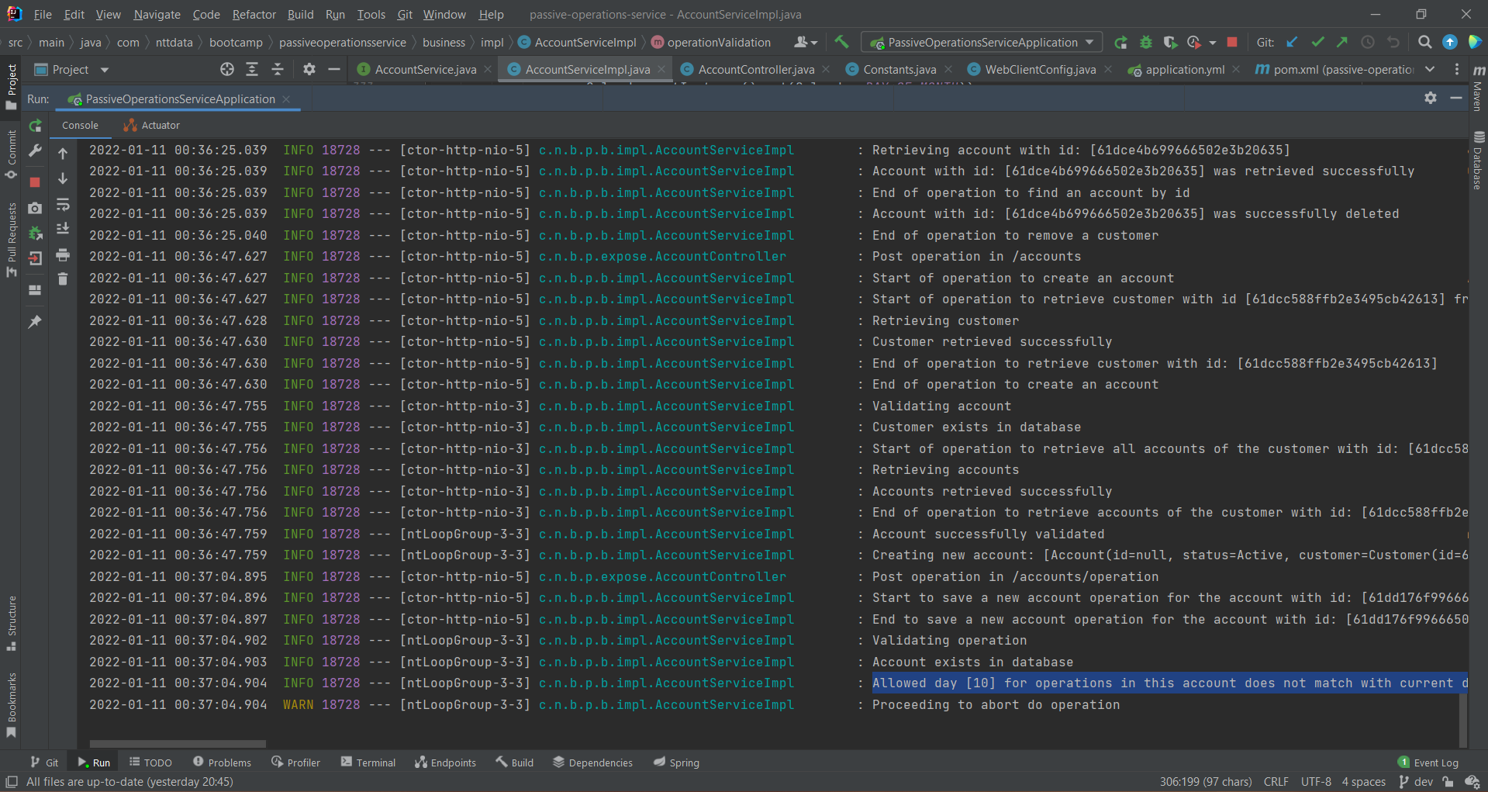

1. Post do operation with error: maximum number of operations reached:

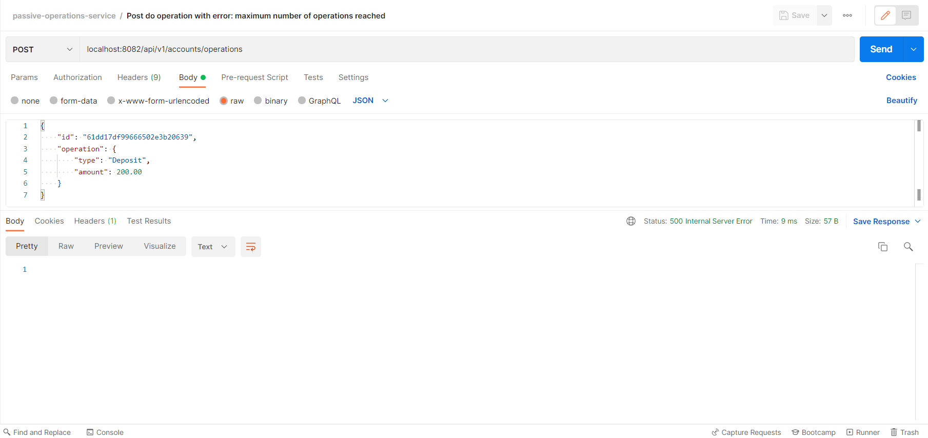

In console, we can see the following logs:

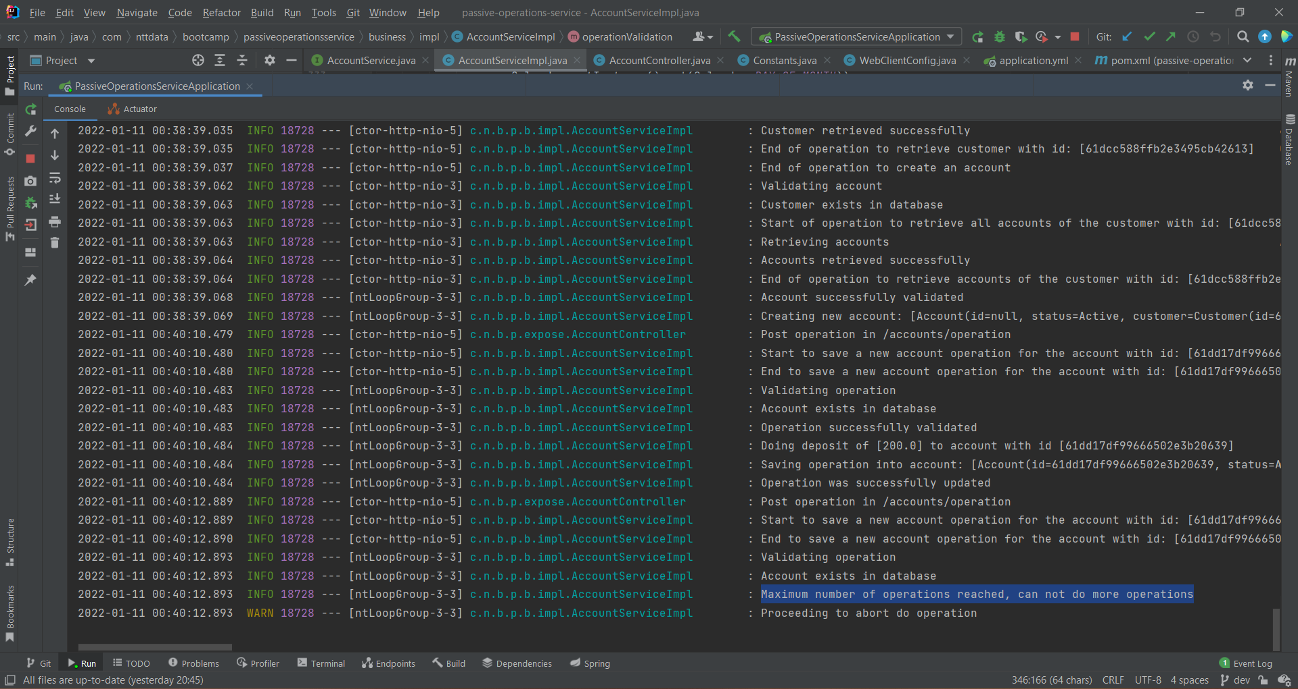

1. Post do operation with error: account not found:

Account was not found, so a 404-not-found status was returned.

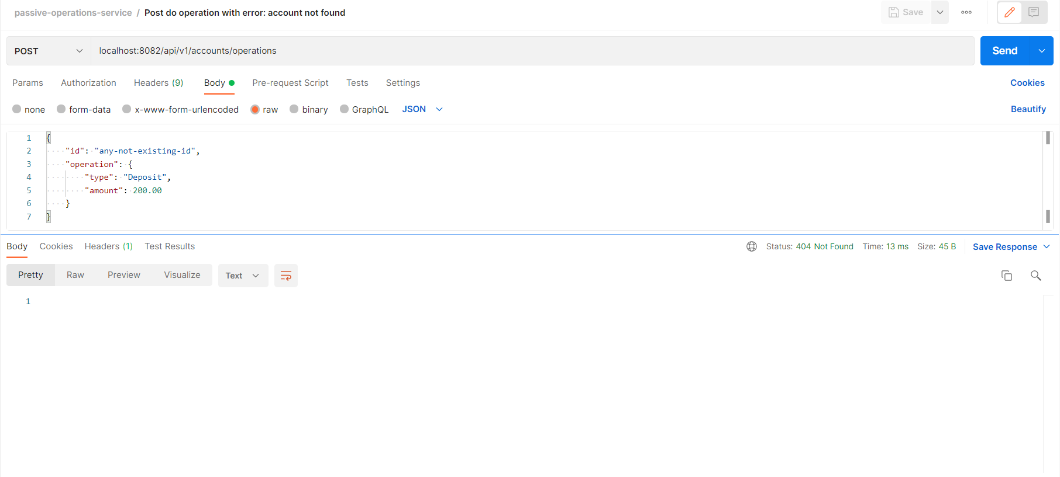

1. Put reset done operations in the month without errors:

For testing purposes, there were added an endpoint to reset the number of done operations in a specified account. As it can be seen in the example, doneOperationsInMonth field has been reset to zero.

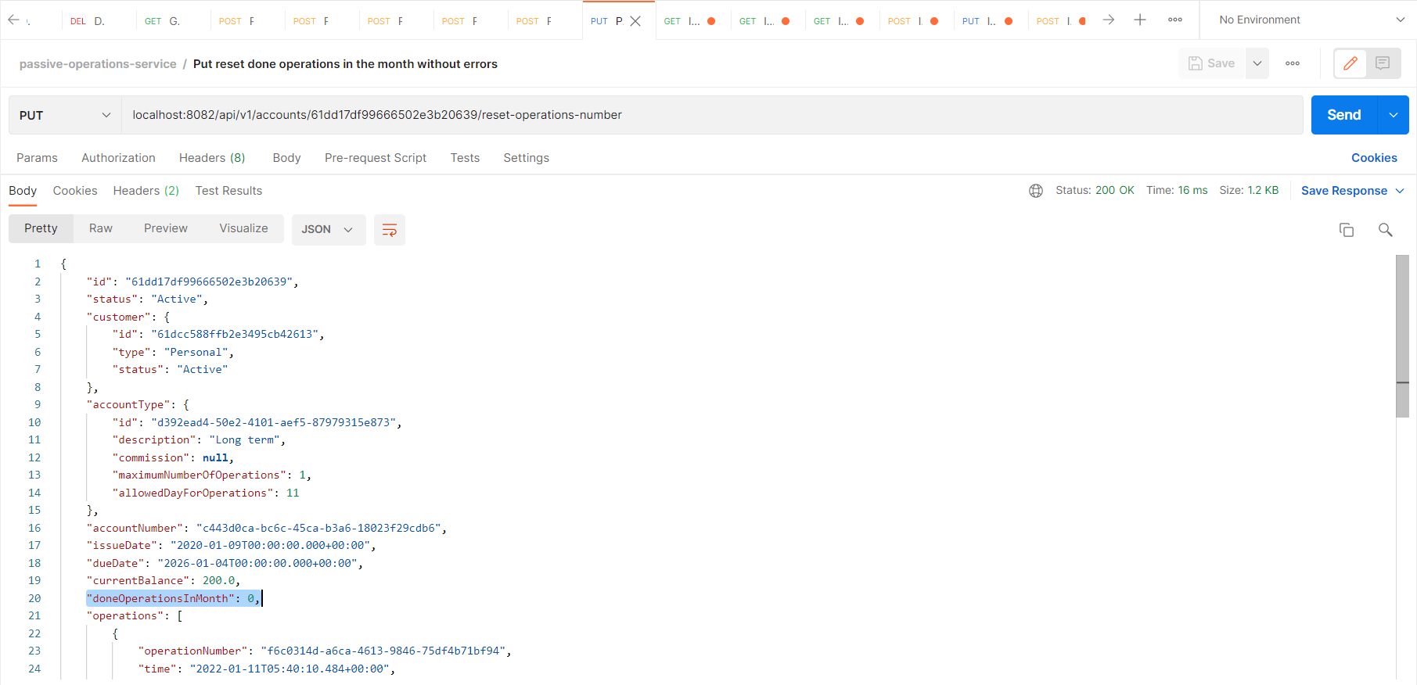

1. Put reset done operations in the month with errors: account not found:

Account was not found, so a 404-not-found status was returned.

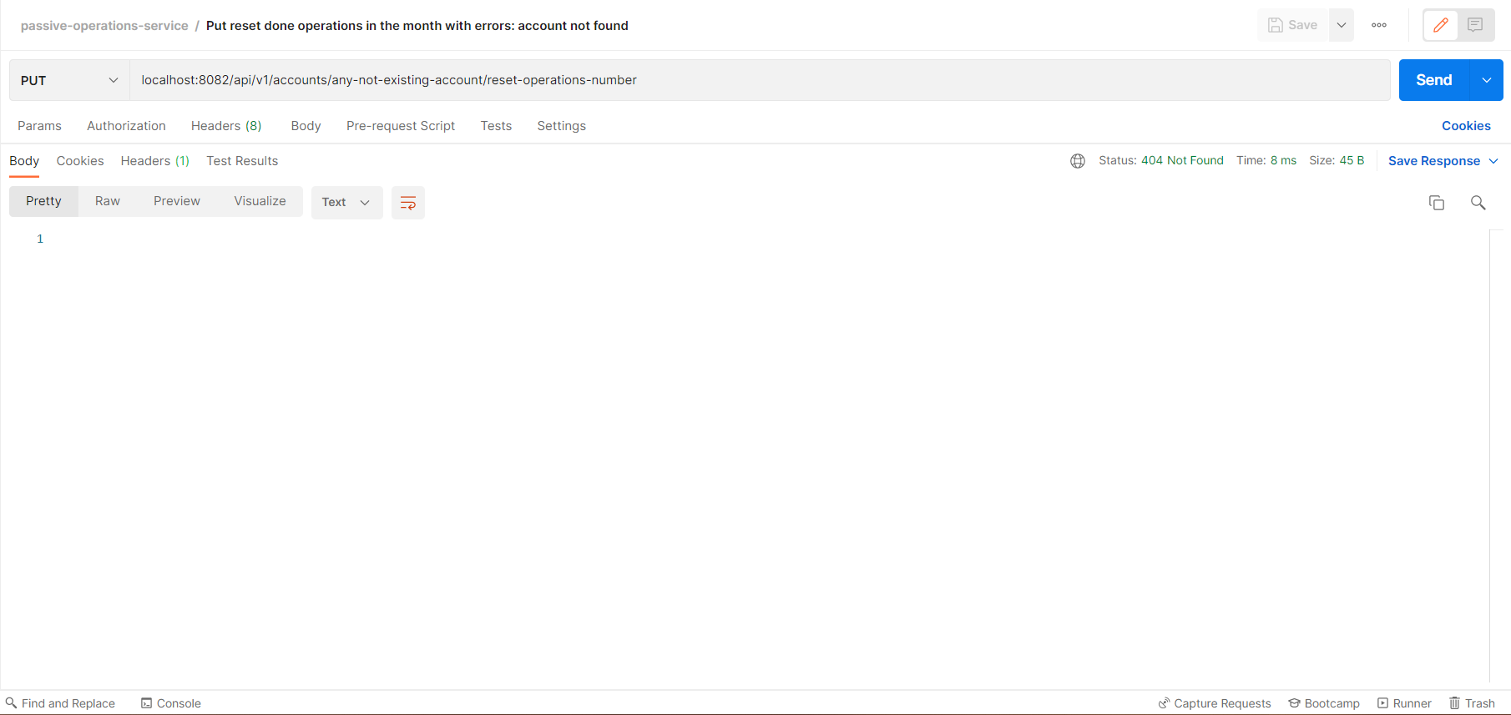

1. Get operations by account id:

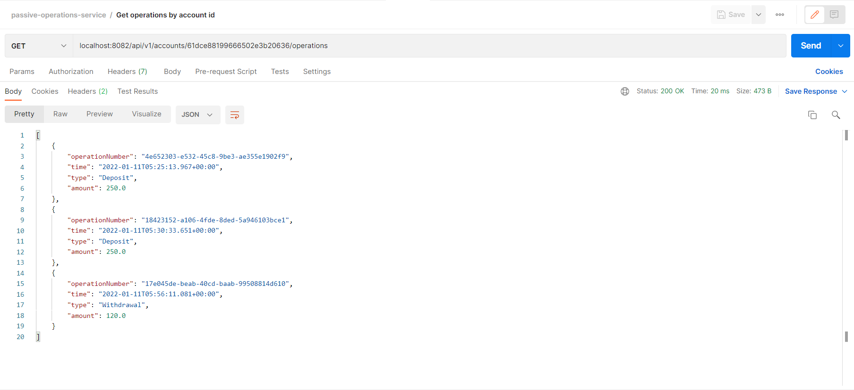

1. Get balances by customer id:

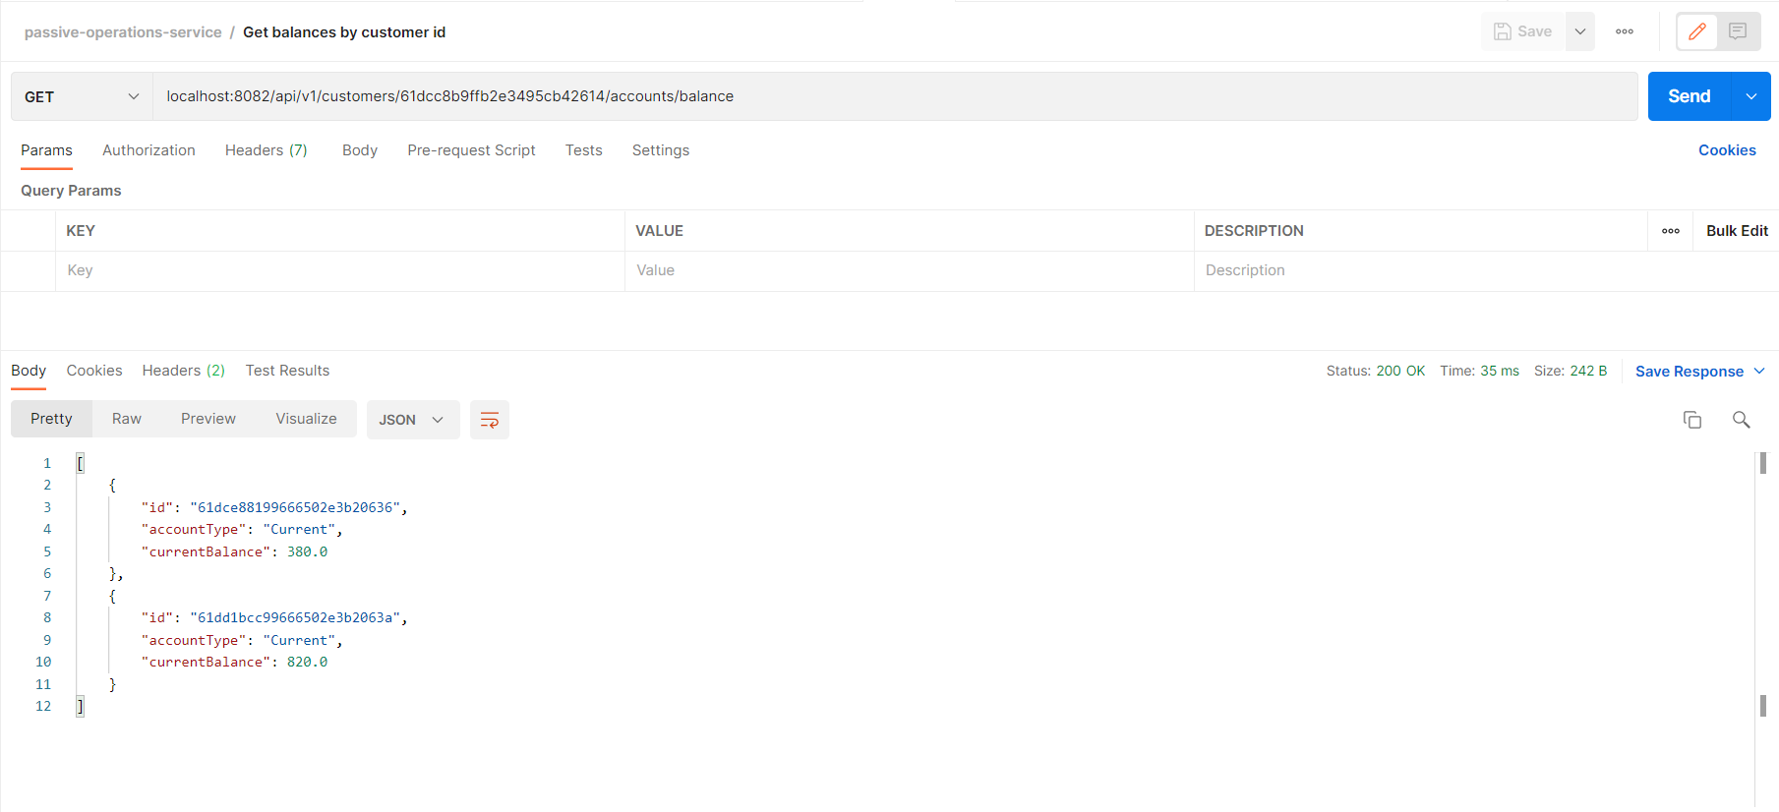

1. Post new personal vip account without error:

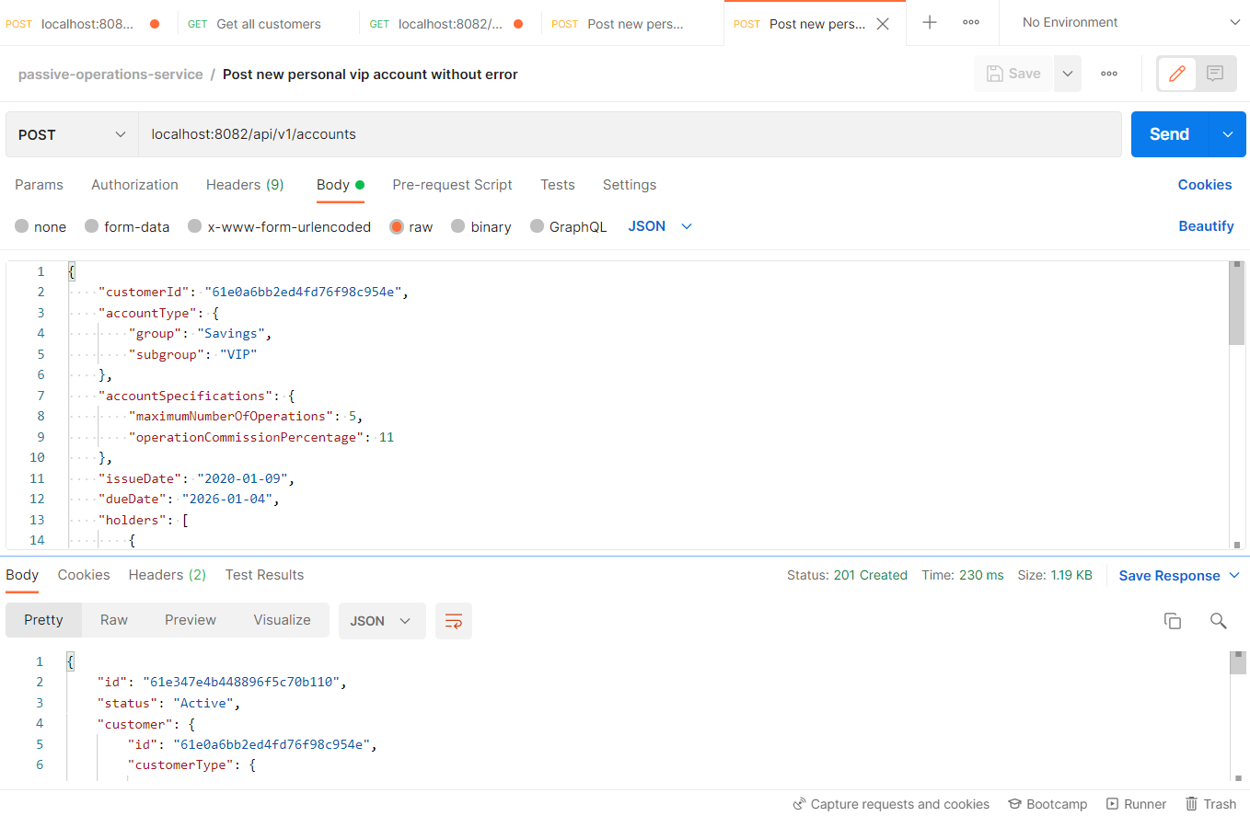

1. Post new personal vip account with error: No credits for customer:

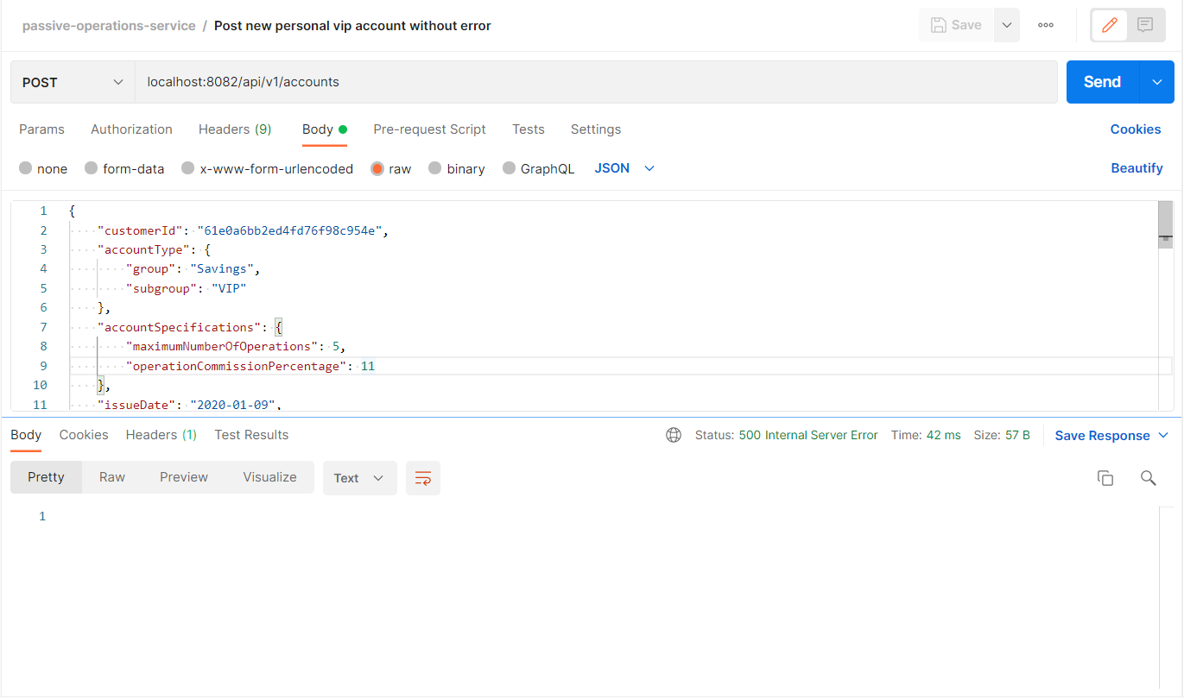

In console, we can see the following logs:

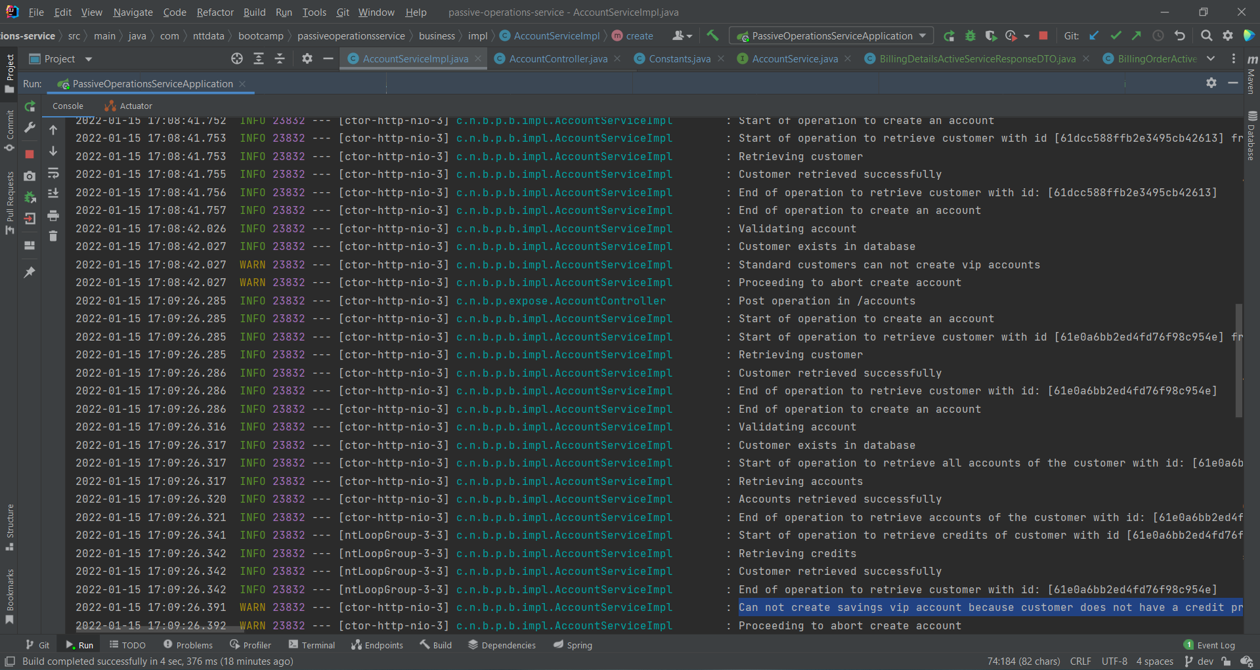

1. Post new business pyme account without error:

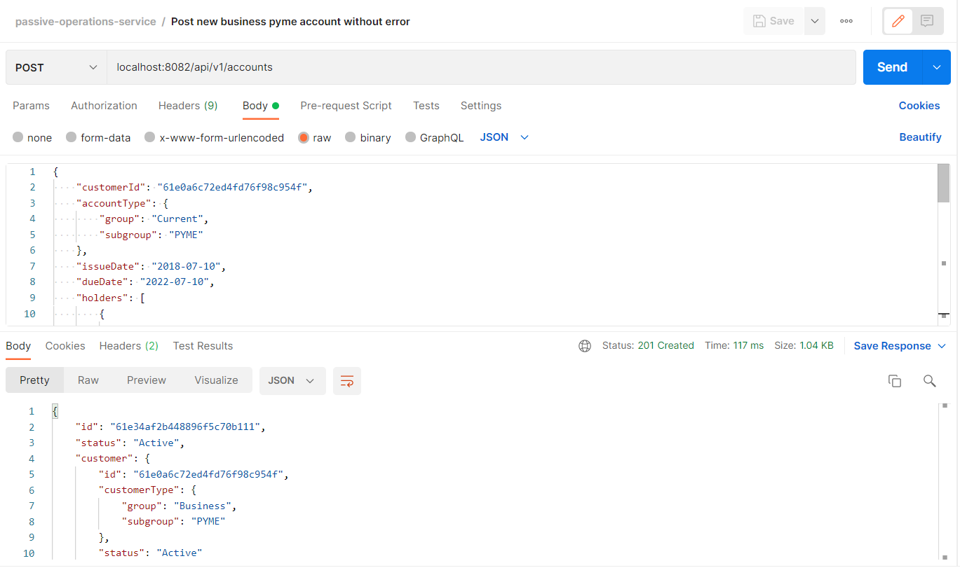

1. Post new business pyme account with error: No credits for customer

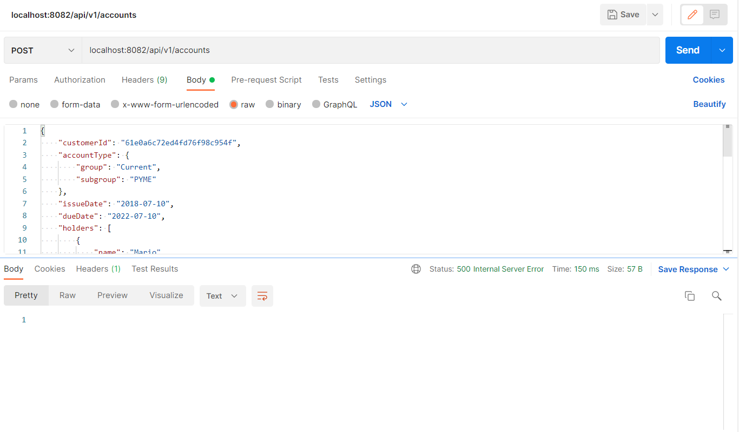

In console, we can see the following logs:

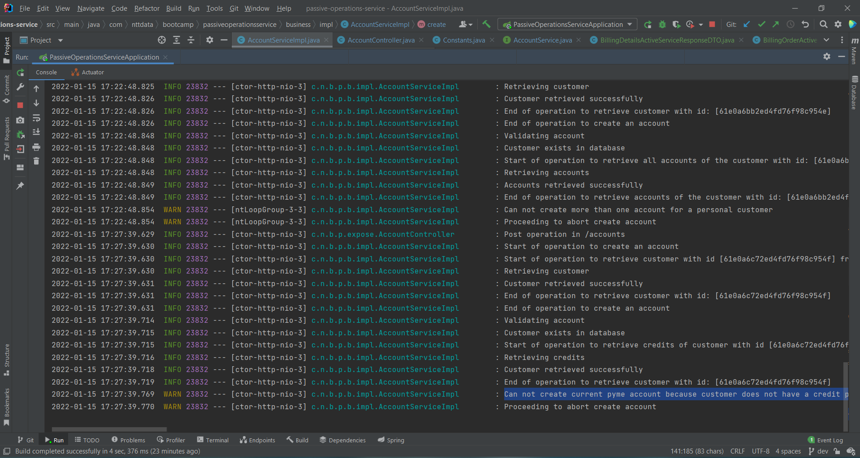

1. Post do transfer without error:

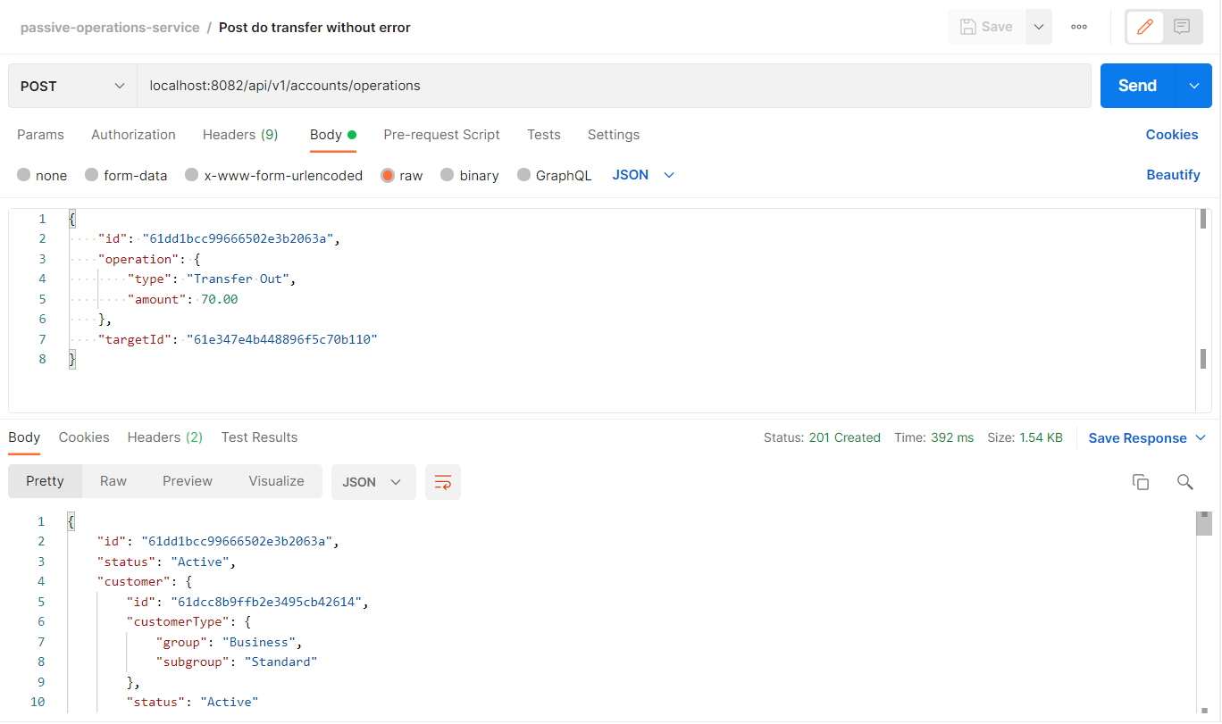

**ACTIVE-OPERATIONS-SERVICE:**

1. Post new personal credit without error:

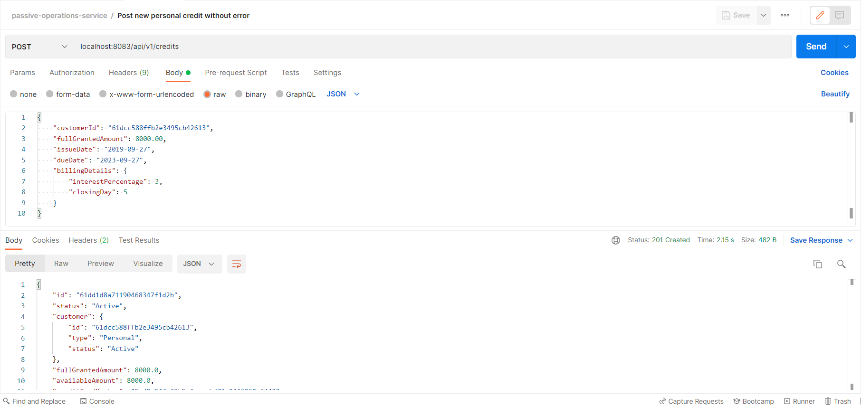

1. Post new personal credit with error: personal customers can only have one credit:

When attempting to create another credit for the same customerId of operation 1, we get a 500-internal-server-error response, because personal customers can only have one credit.

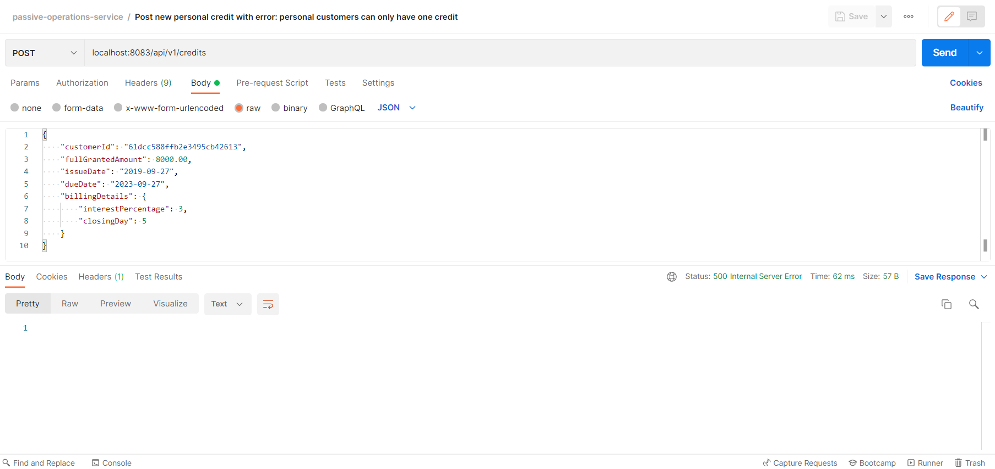

In console, we can see the following logs:

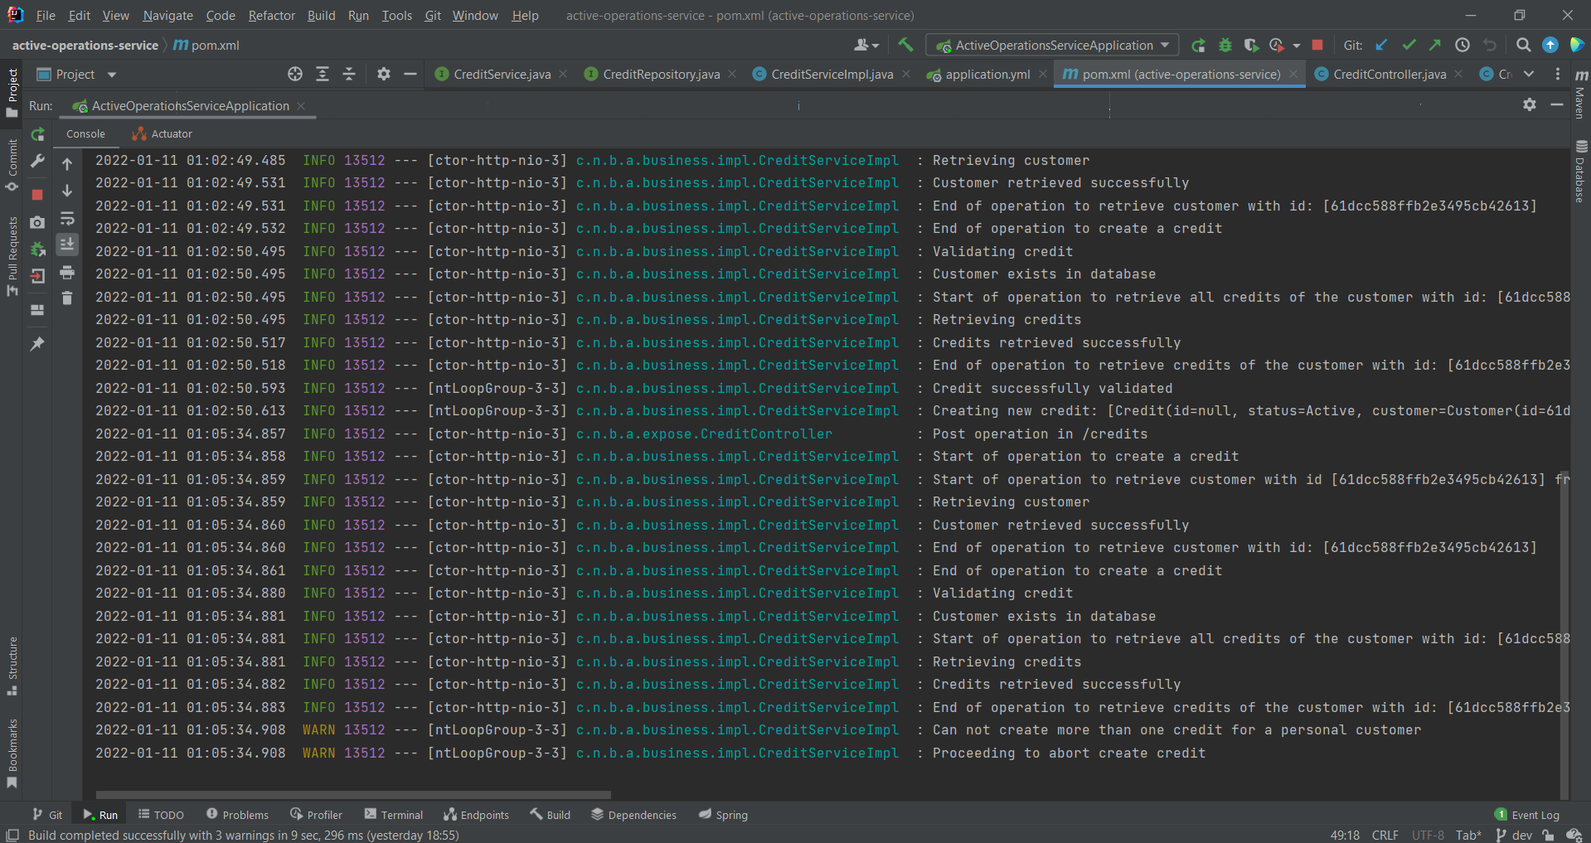

1. Post new business credit without error:

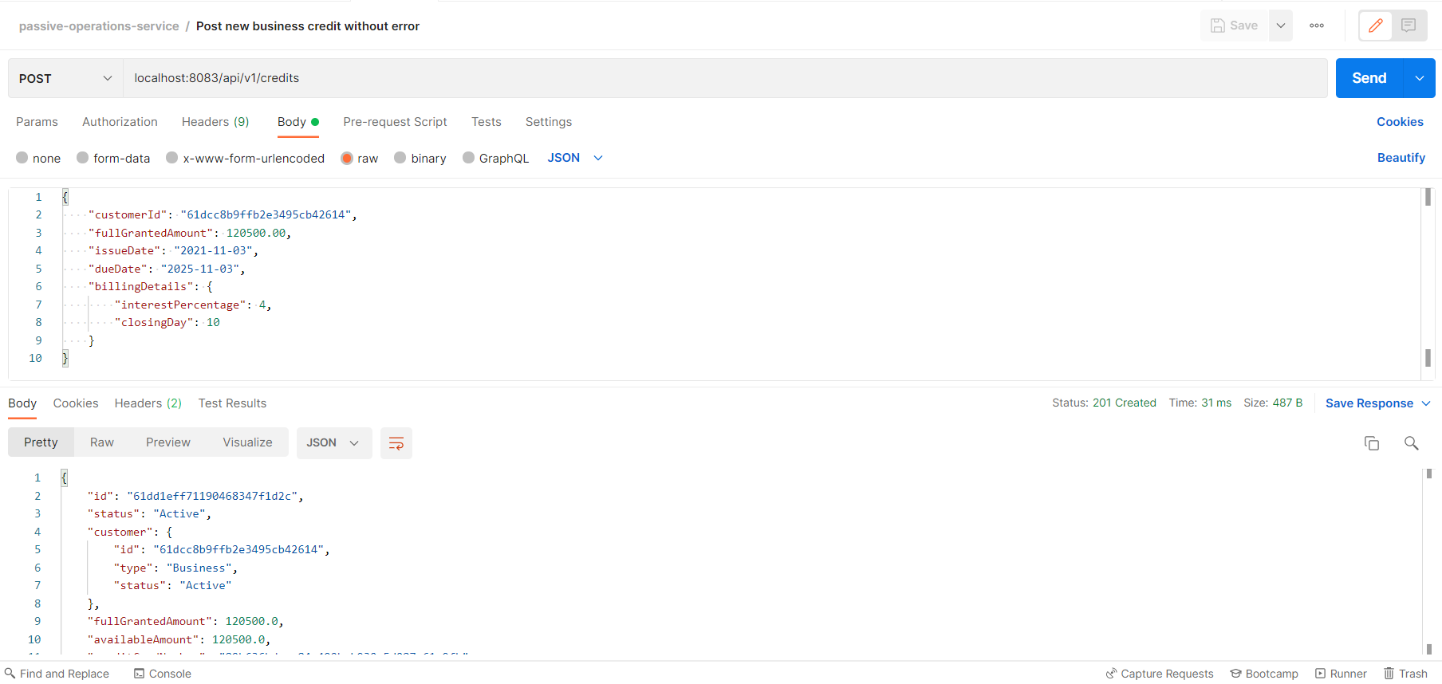

1. Post new credit with error: customers cannot create credits when they have blocked status:

When attempting to create a credit for a blocked customer, we get a 423-locked response.

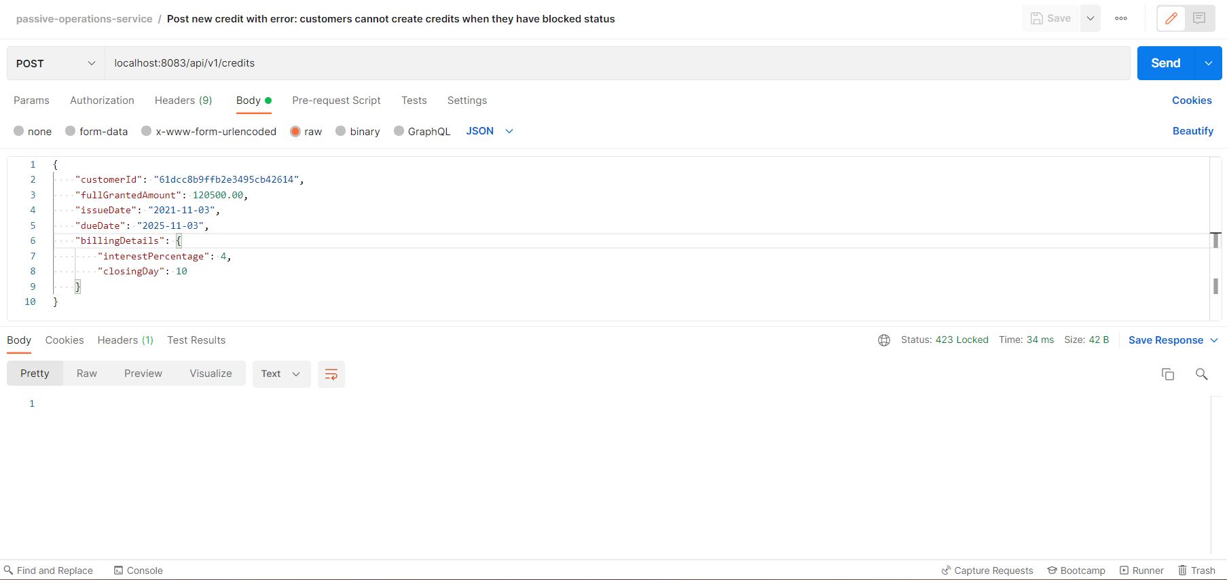

In console, we get the following logs:

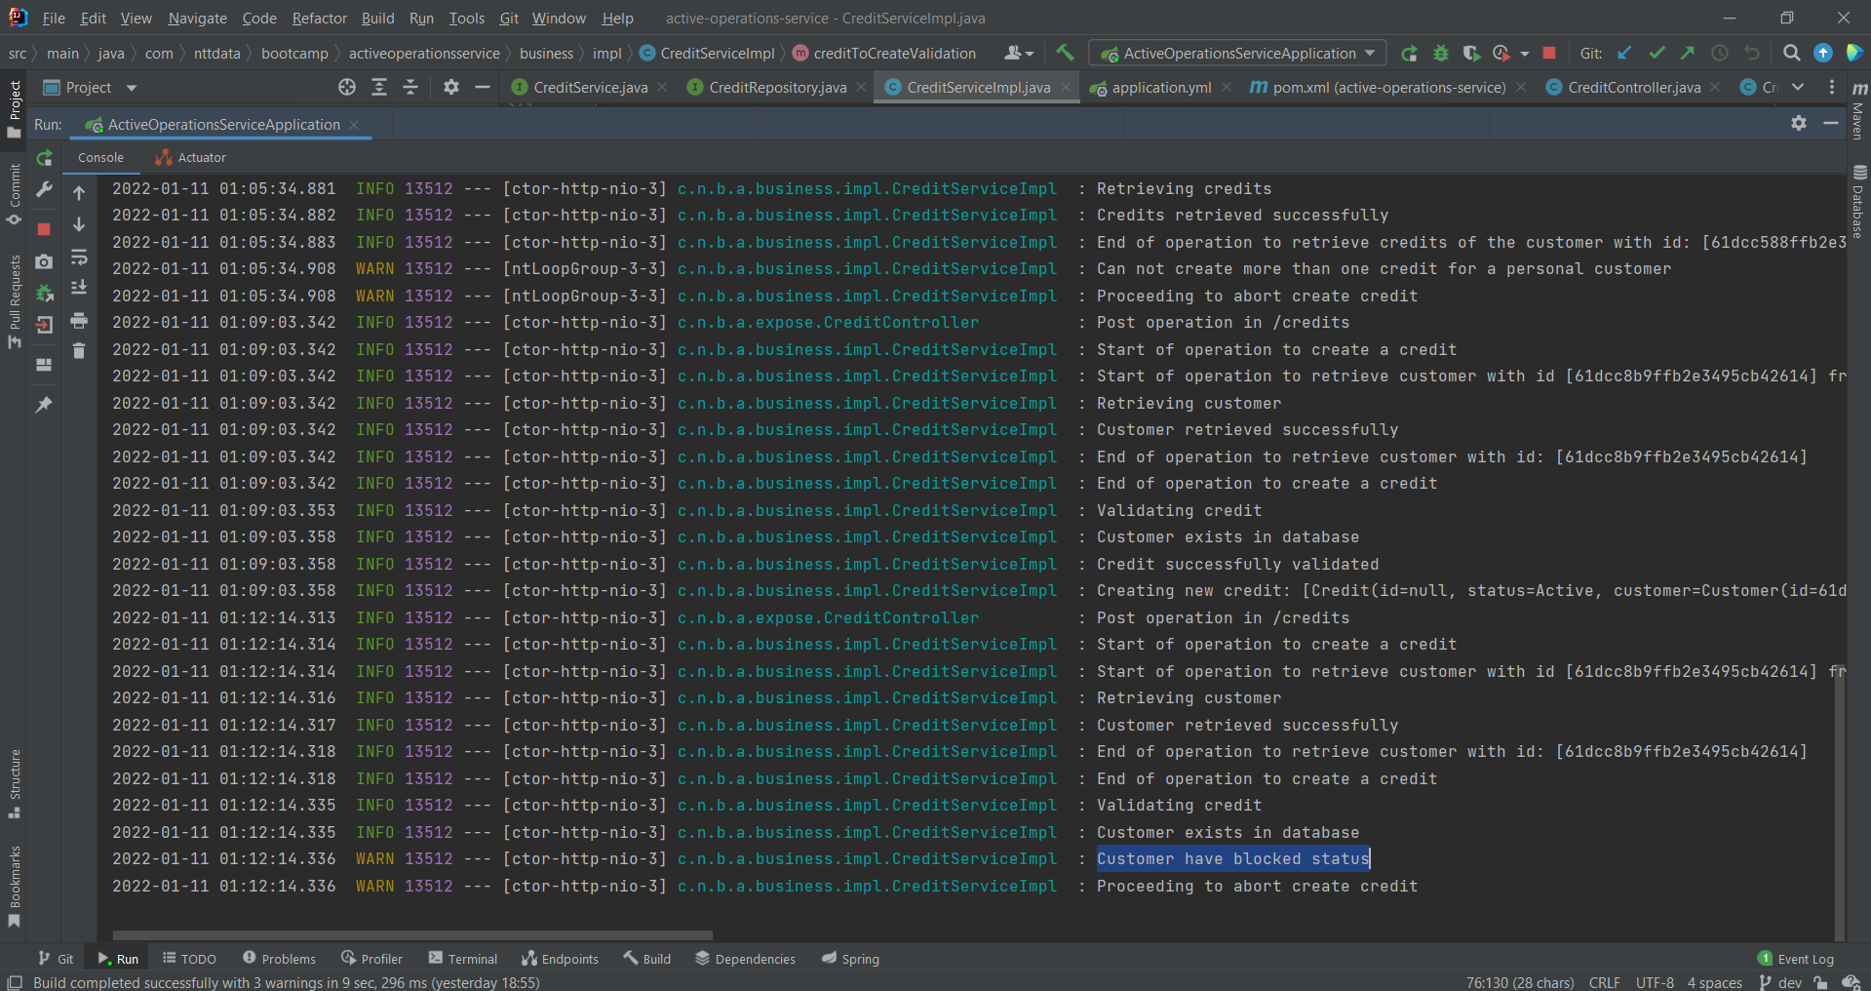

1. Post new credit with error: credit does not have billing details:

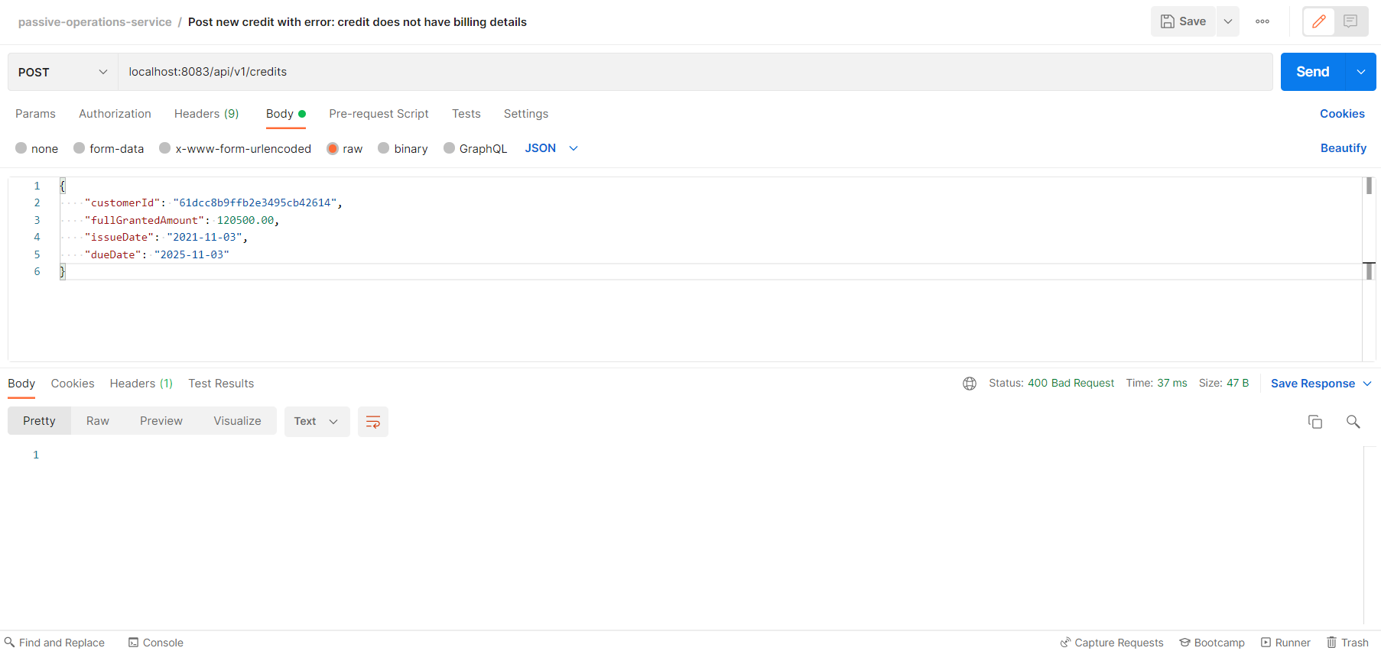

In console, we see the following logs:

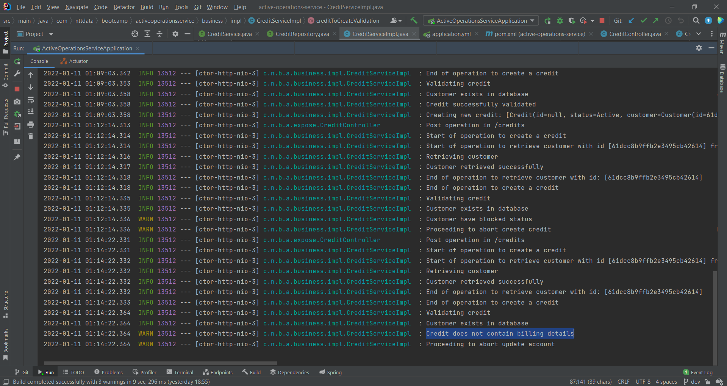

1. Get all credits:

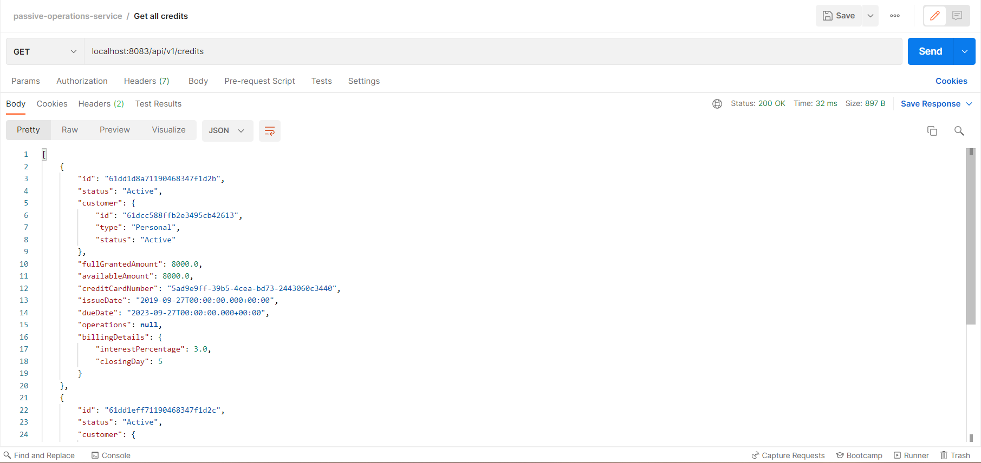

1. Get credit by id:

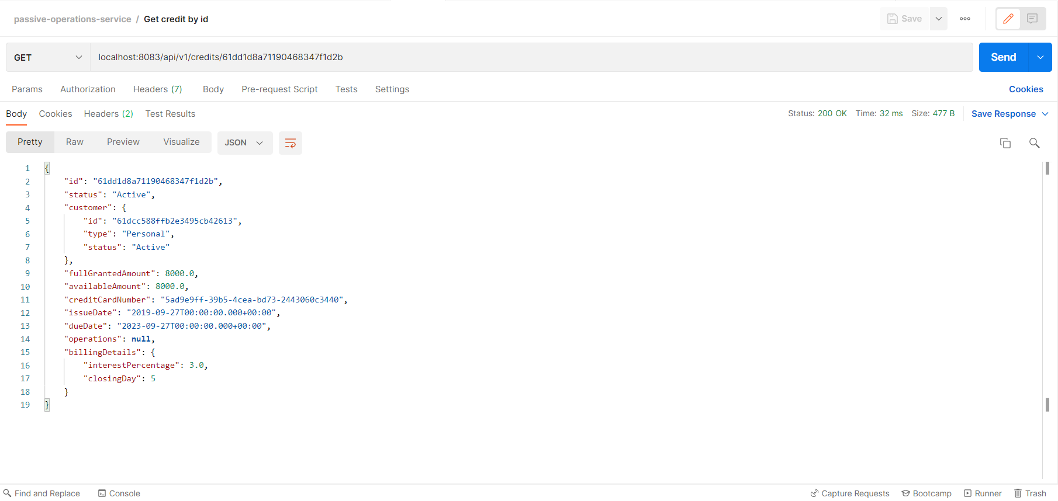

1. Put credit without error:

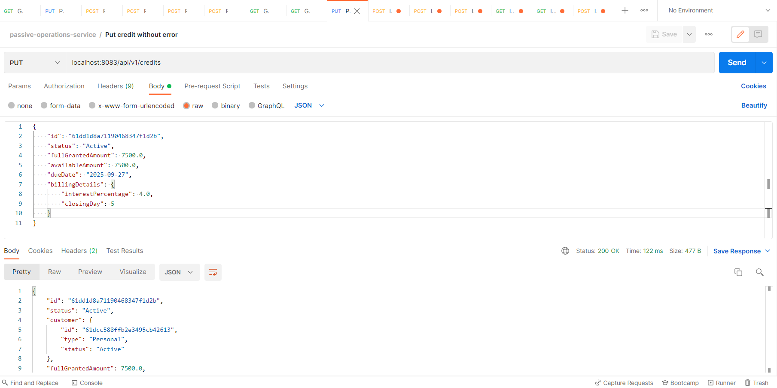

1. Put credit with error: credit does not have billing details:

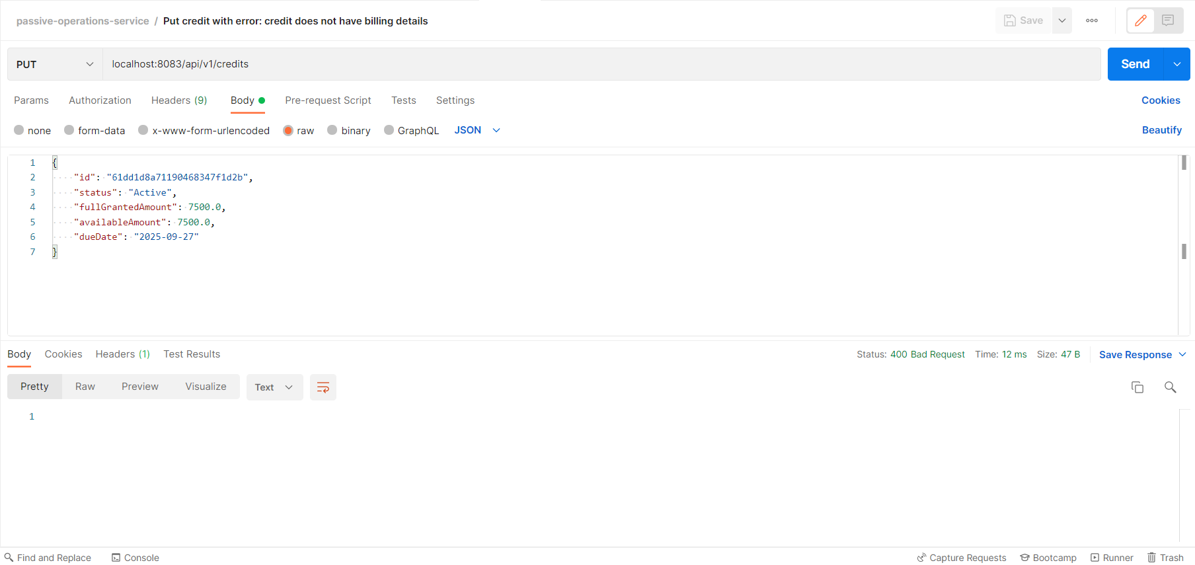

In console, we can see the following logs:

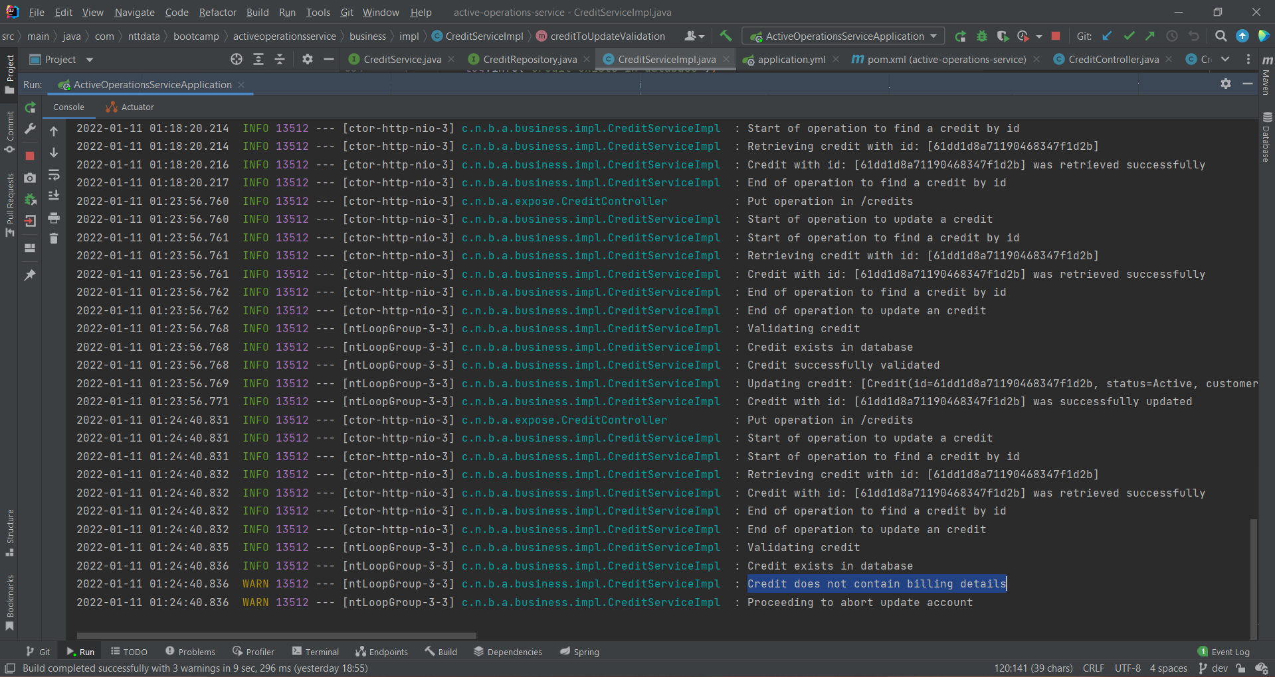

1. Put credit with error: available amount is greater than full granted amount:

Available amount cannot be greater than the full granted amount.

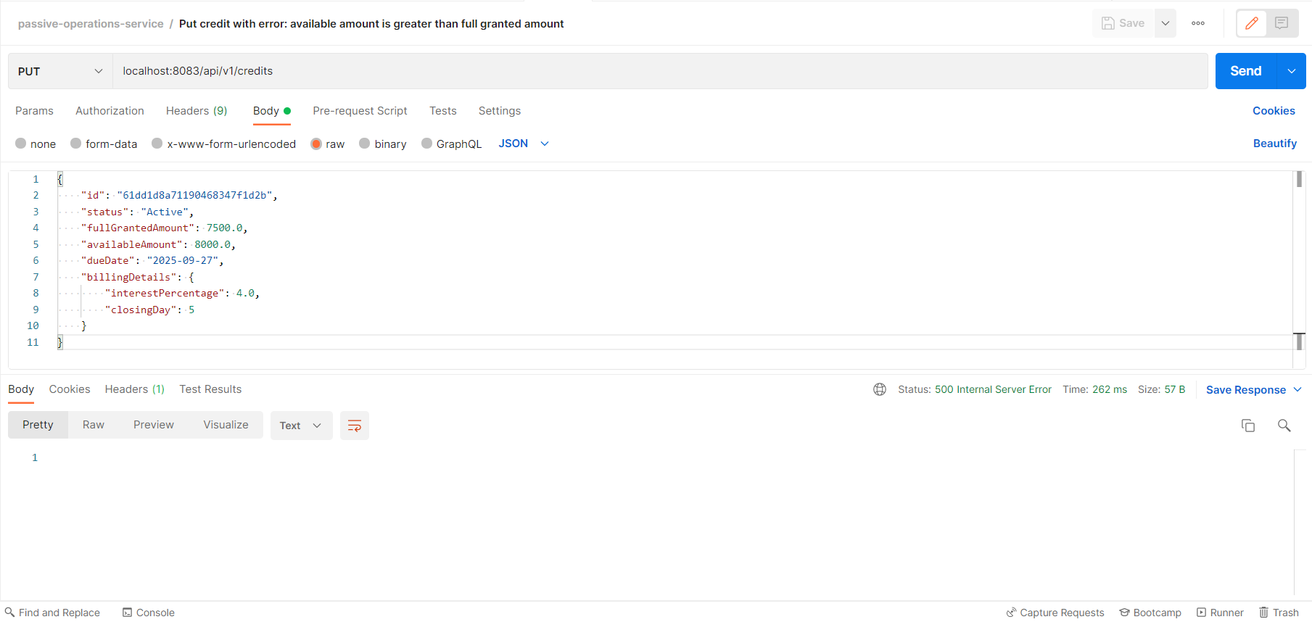

In console, we can see the following logs:

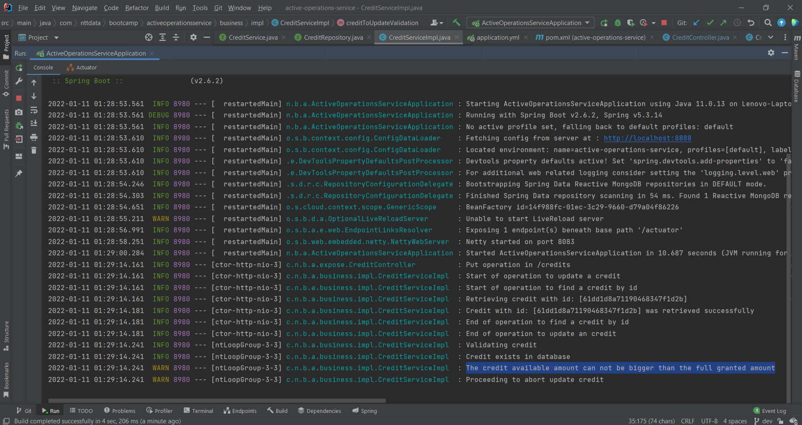

1. Put credit with error: credit not found:

Credit was not found, so a 404-not-found status was returned.

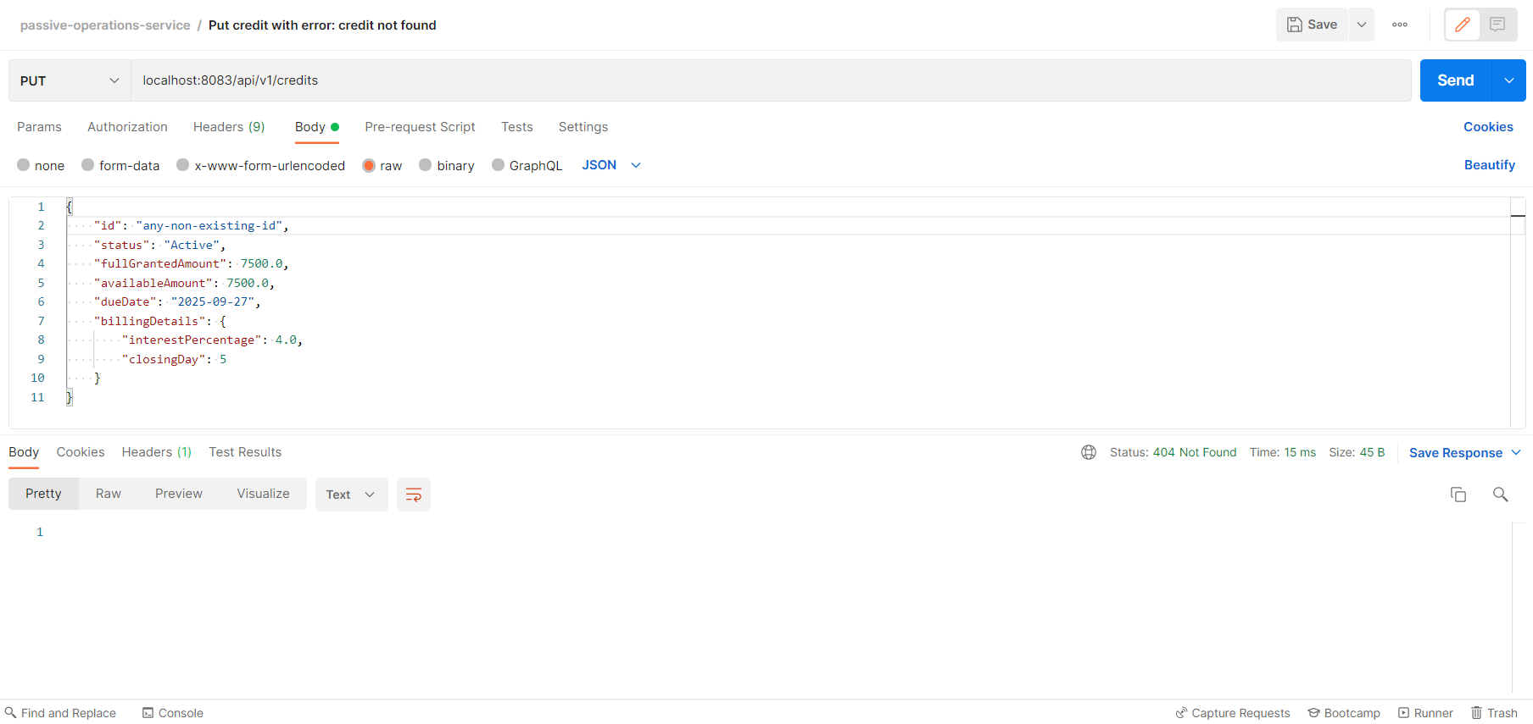

1. Delete credit by id without error:

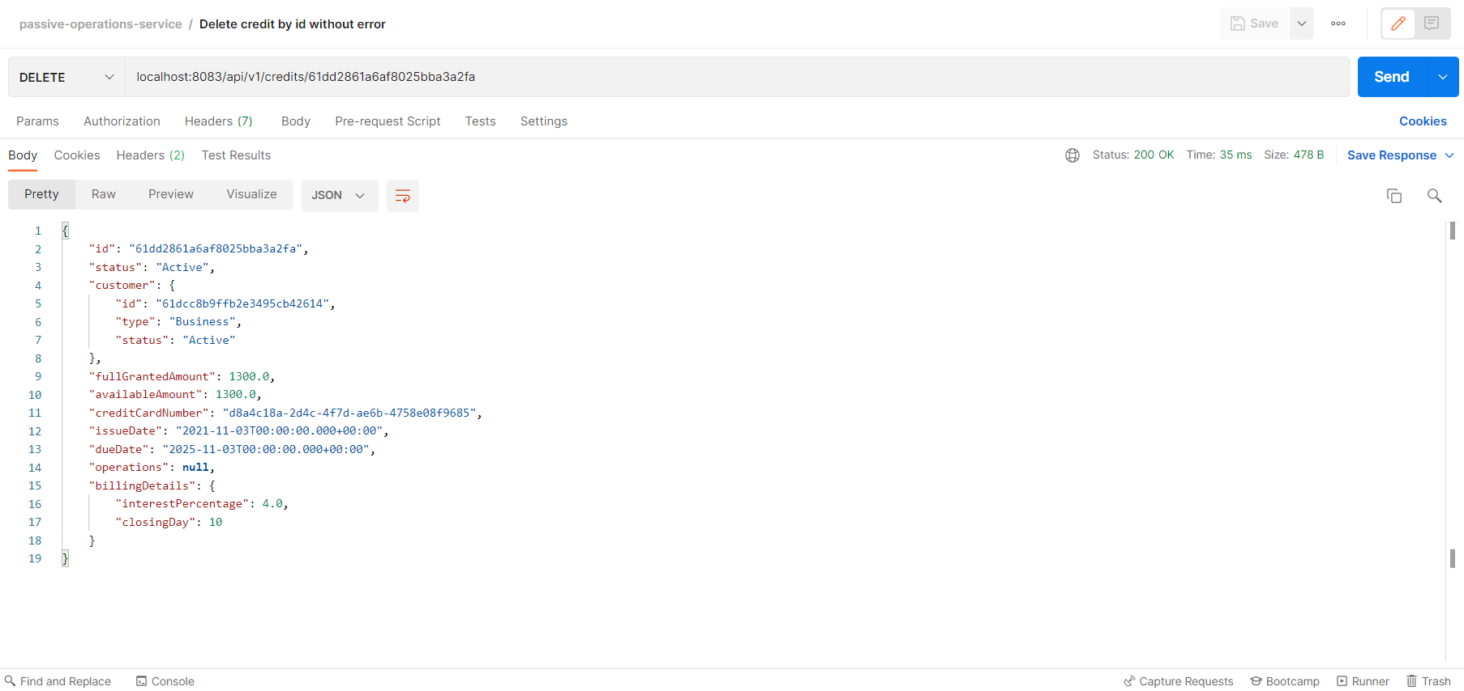

1. Delete credit by id with error: credit not found:

Credit was not found, so a 404-not-found status was returned.

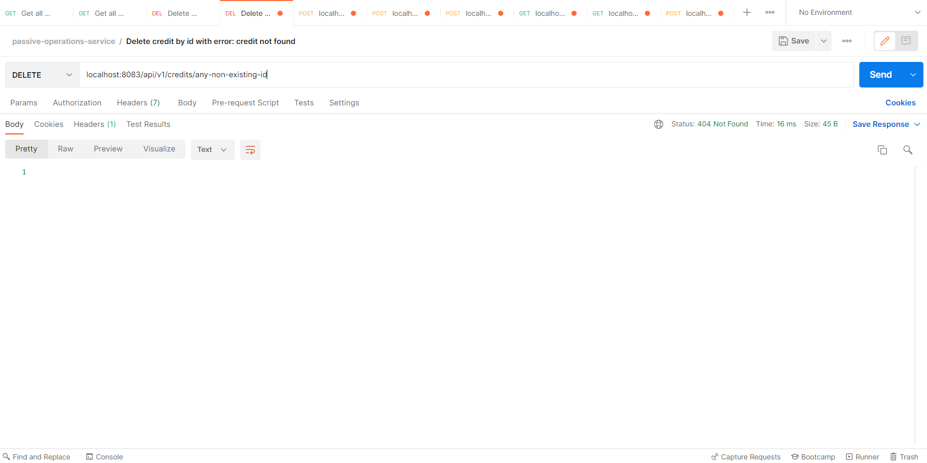

1. Get credits by customer id:

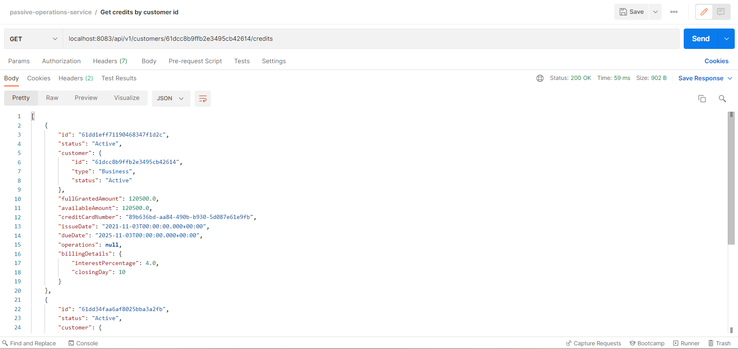

1. Post consume credit without error:

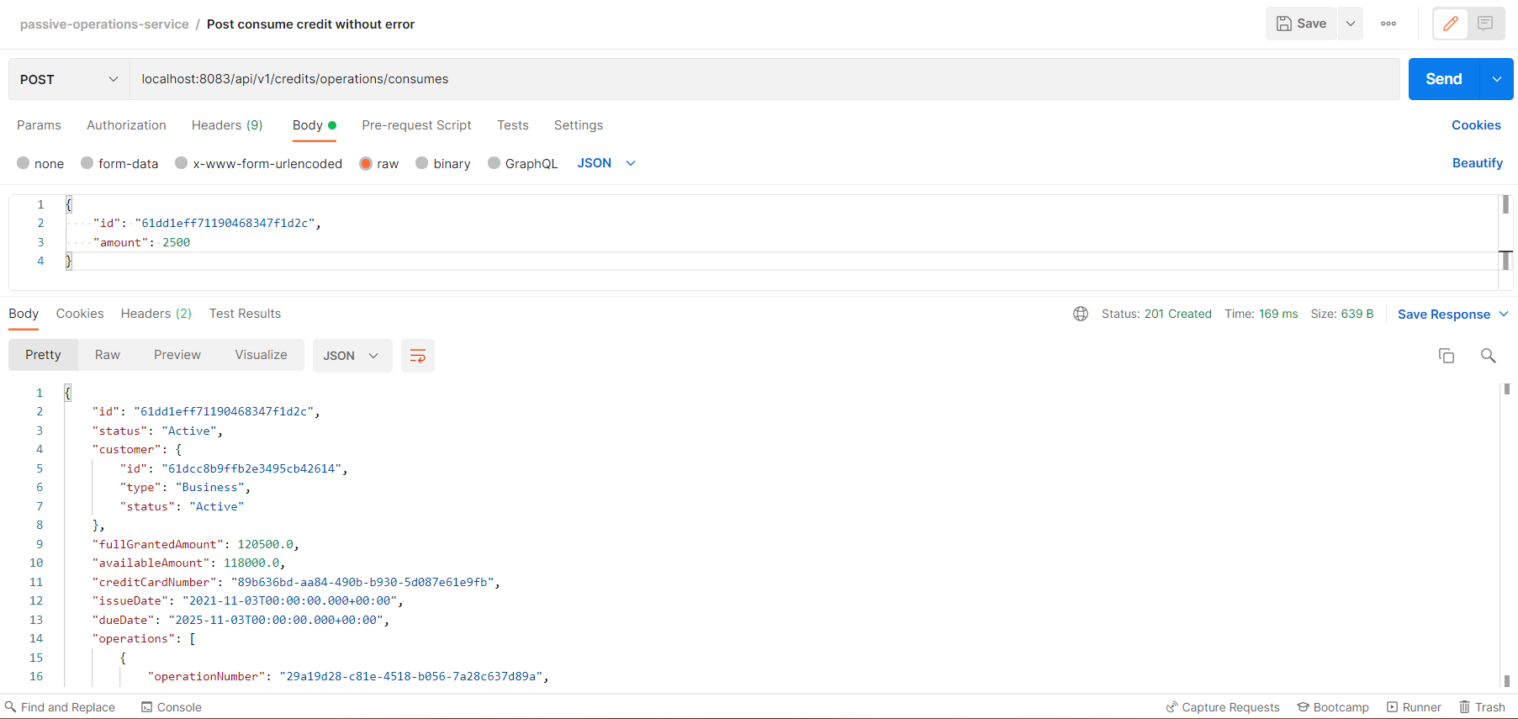

1. Post consume credit with error: credits can not create consumes when they have blocked status

When attempting to create an consume for a blocked credit, we get a 423-locked response.

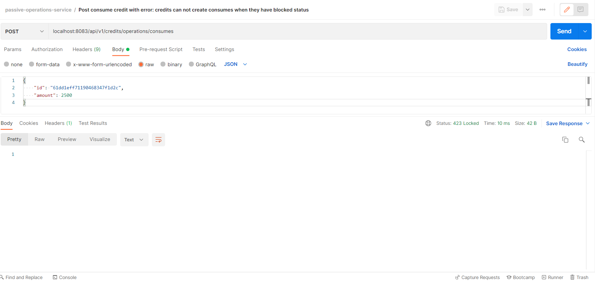

In console, we can see the following logs:

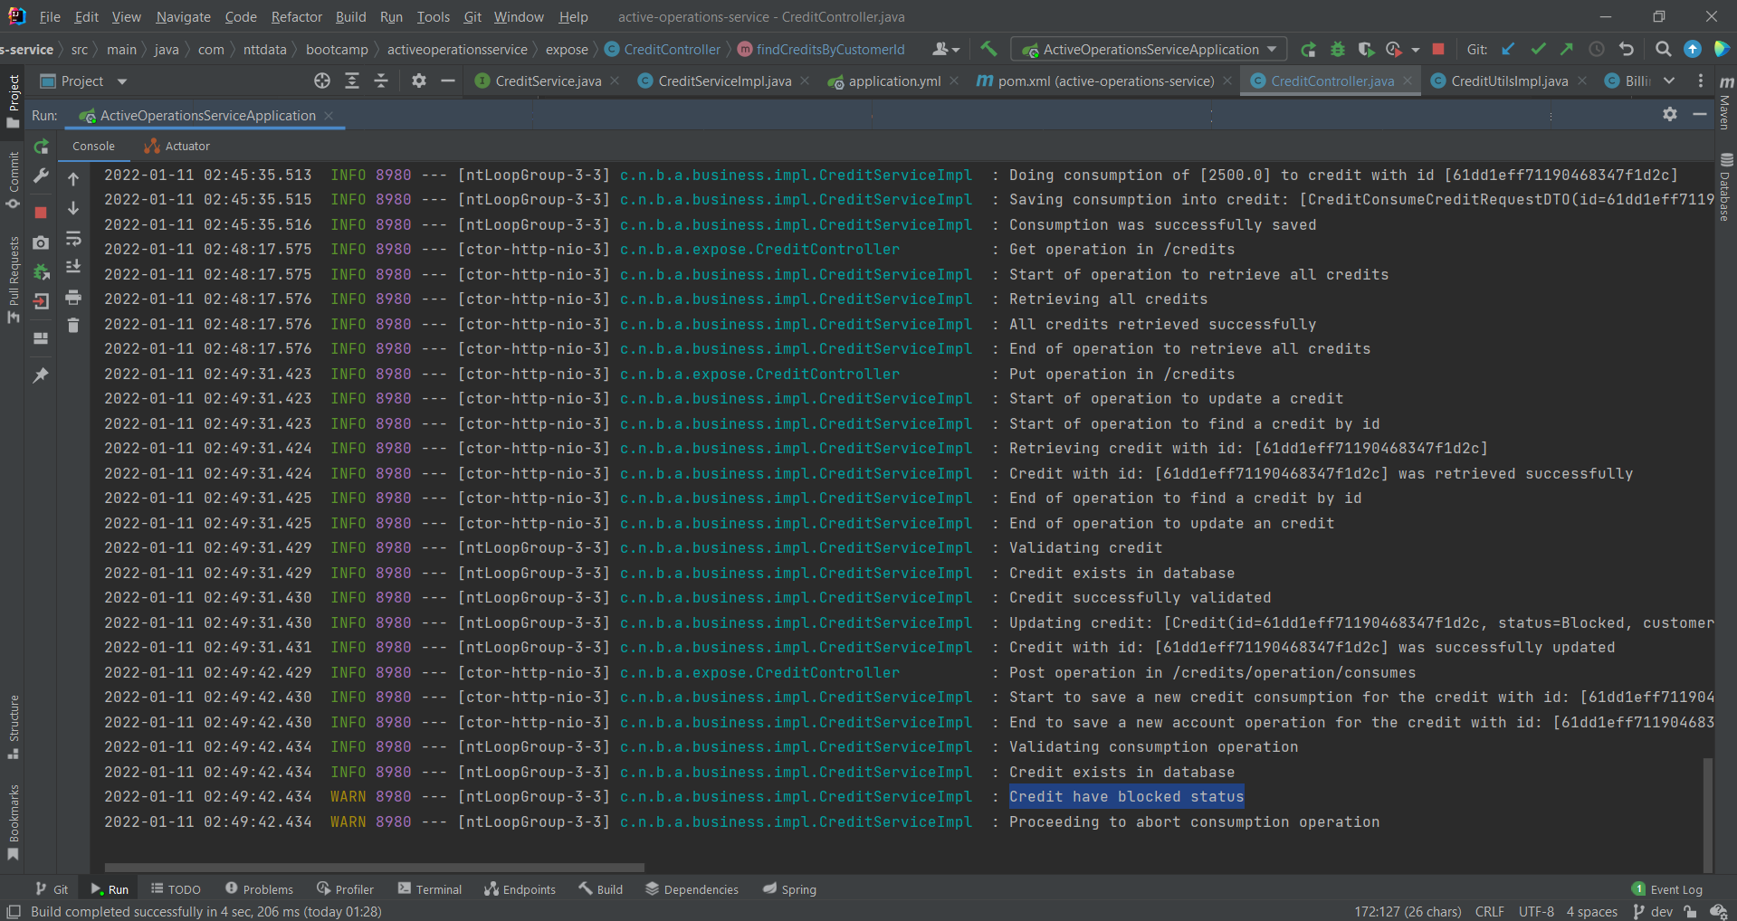

1. Post consume credit with error: credit has insufficient funds:

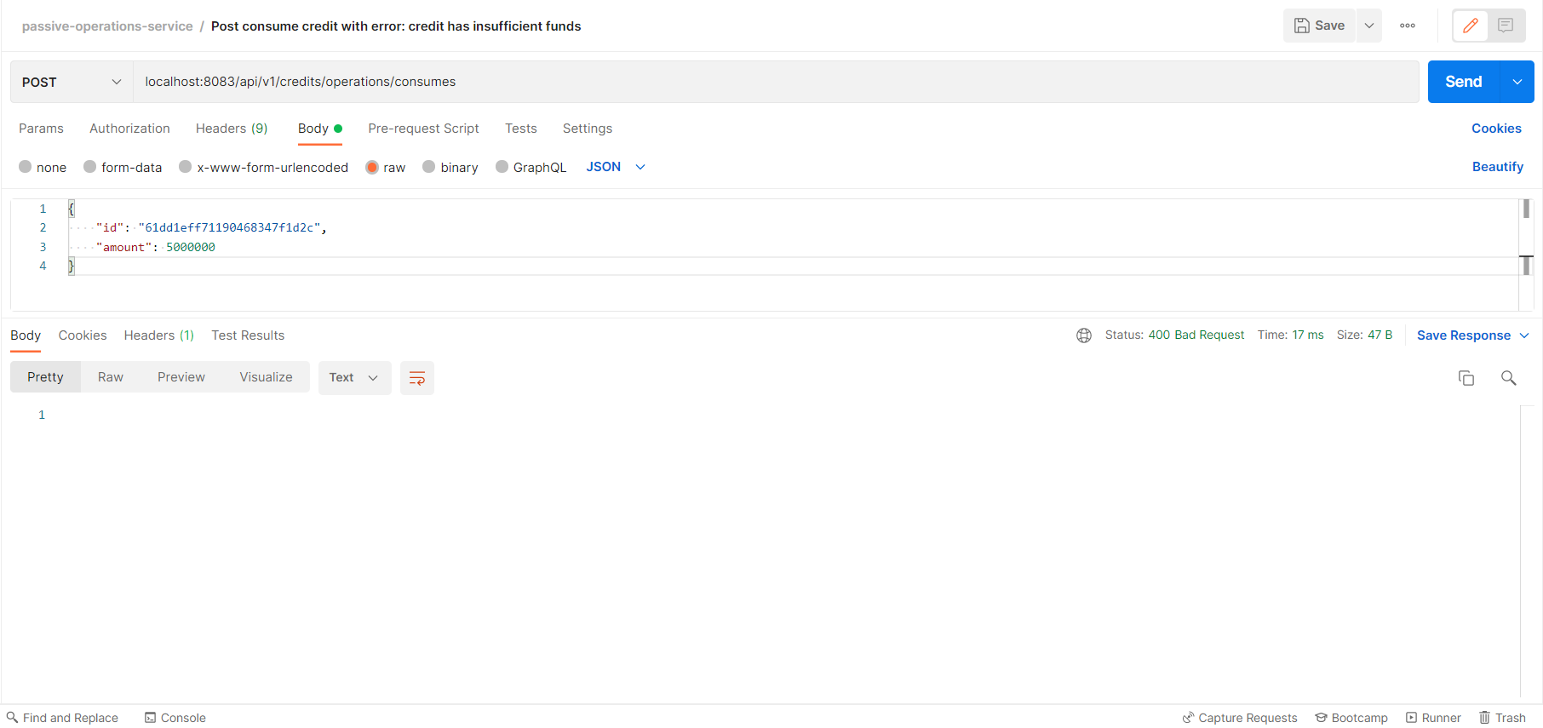

In console, we can see the following logs:

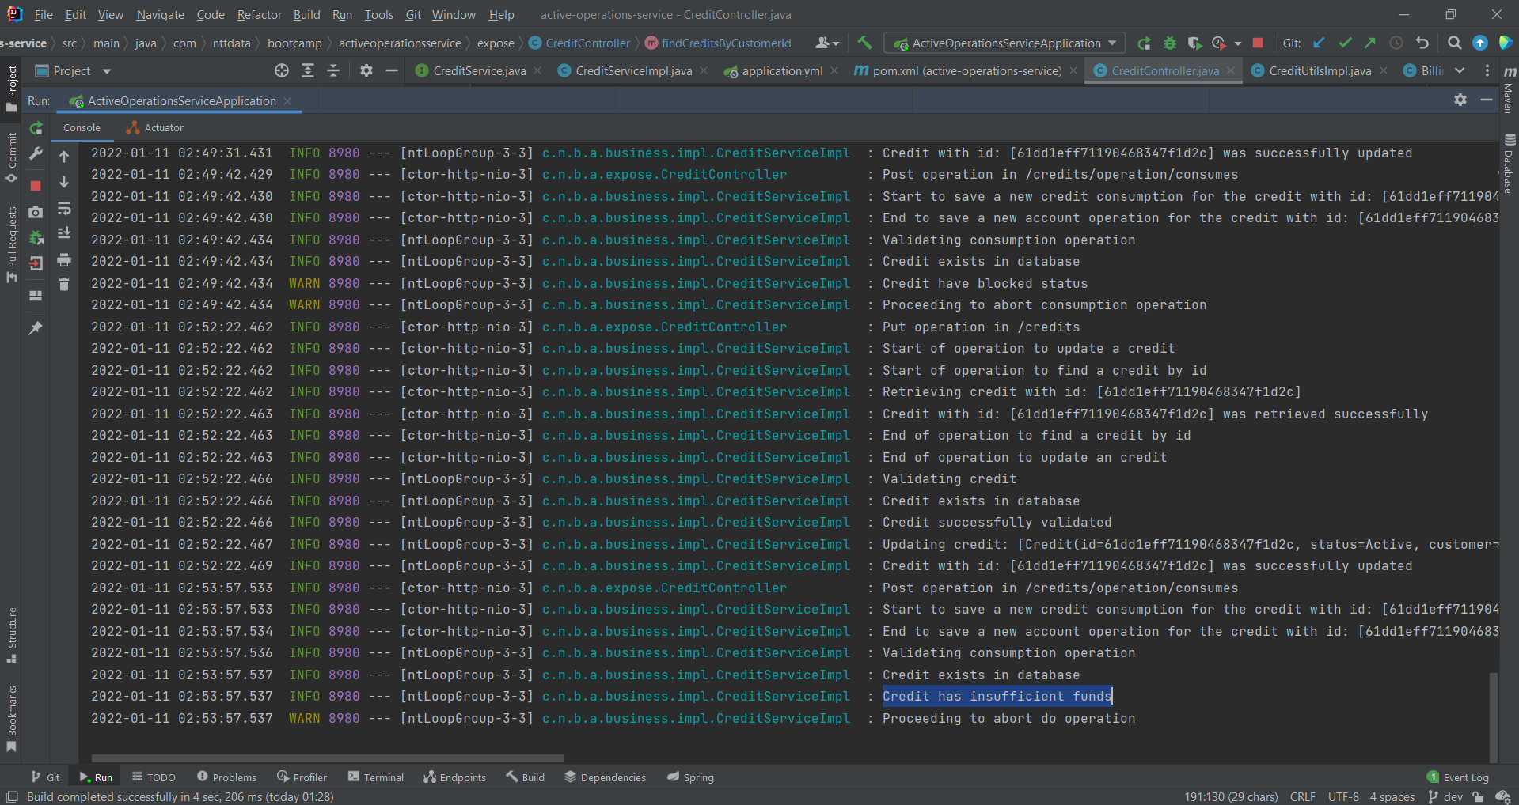

1. Post consume credit with error: credit not found:

Credit was not found, so a 404-not-found status was returned.

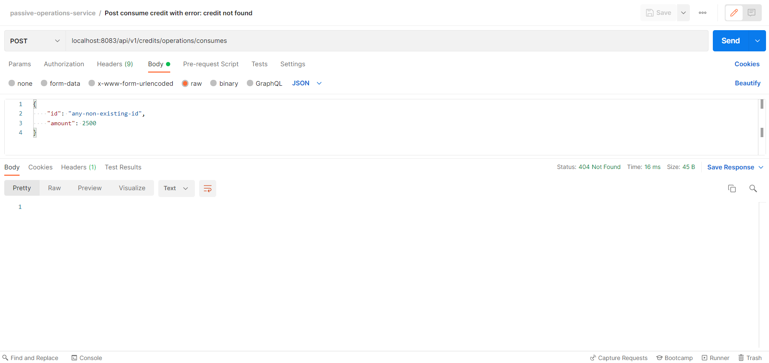

1. Post generate billing order without error:

For testing purposes, this endpoint generates a billing order with a randomly selected amount. Billing orders are used to pay customer’s credit products, so before doing a payment this endpoint must be used for generating a billing order.

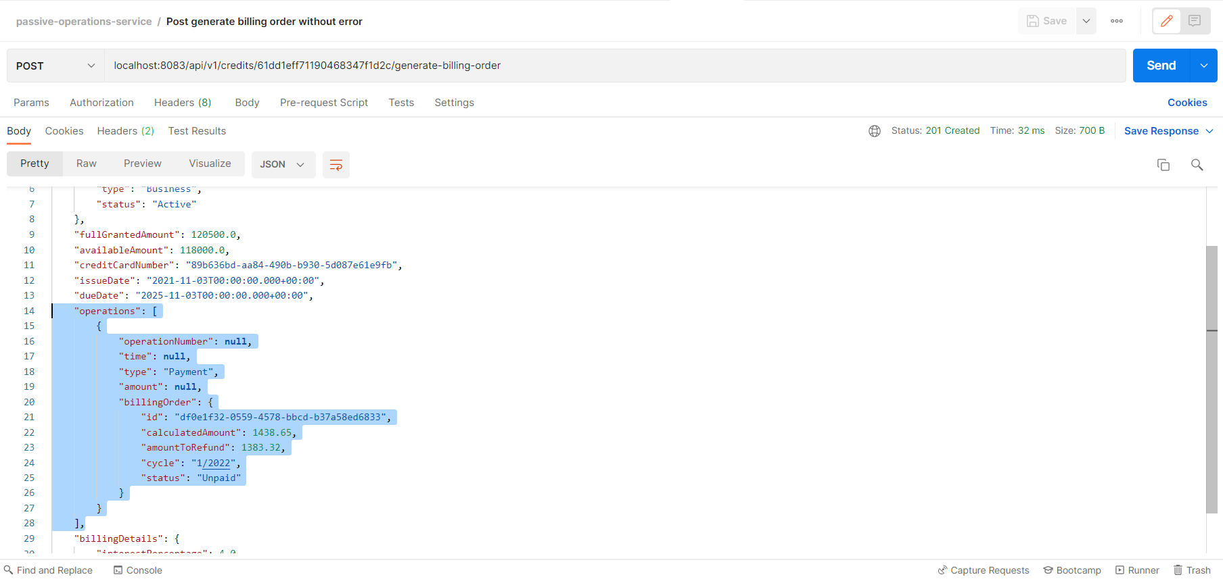

1. Post generate billing order with error: customer does not have debts in credit:

If the credit card available amount is equal to the full granted amount, that means that the customer is not owing for any consumption and, because of that, a billing order can not be generated.

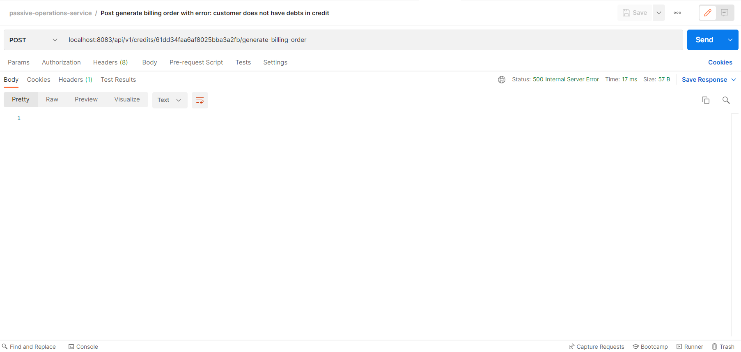

In console, we can see the following logs:

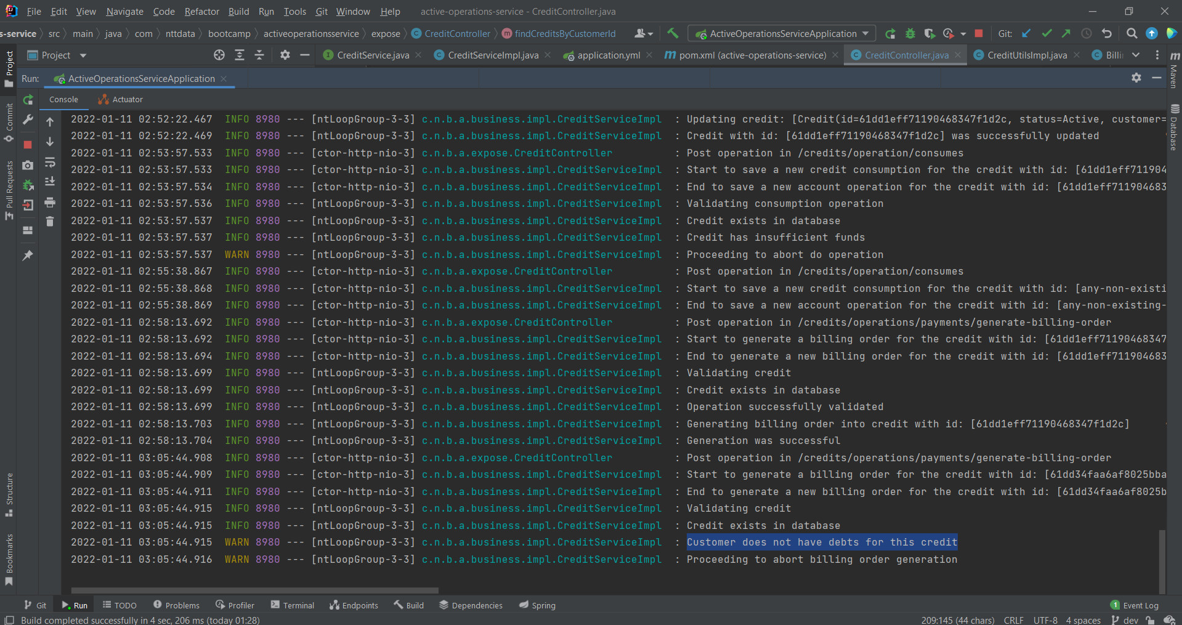

1. Post generate billing order with error: credit not found:

Credit not found, so a 404-not-found status was returned.

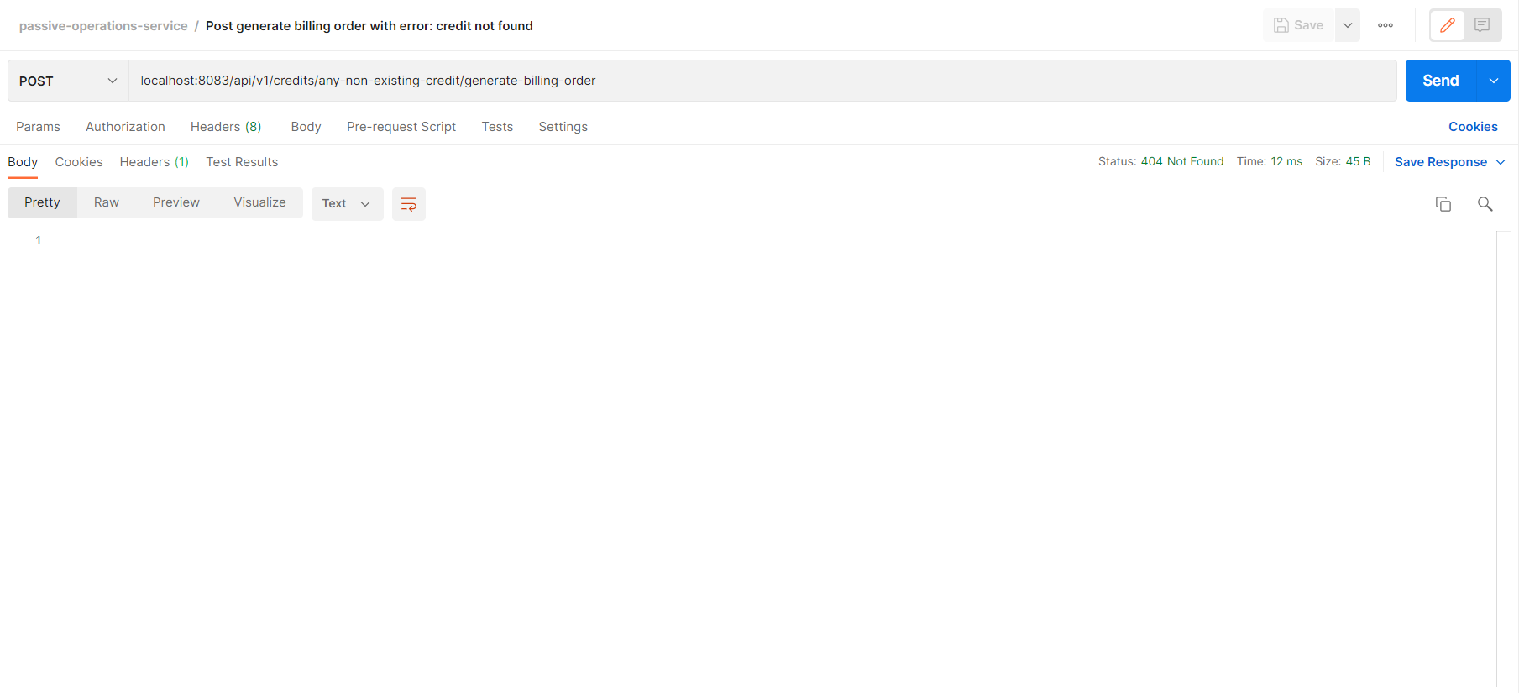

1. Post pay credit without error:

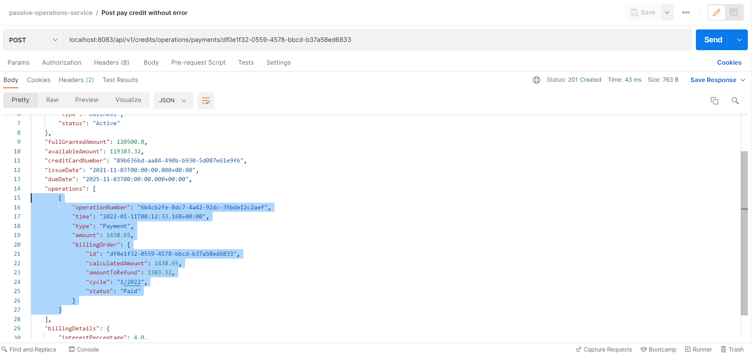

1. Post pay credit with error: billing order not found:

Billing order not found, so a 404-not-found status was returned.

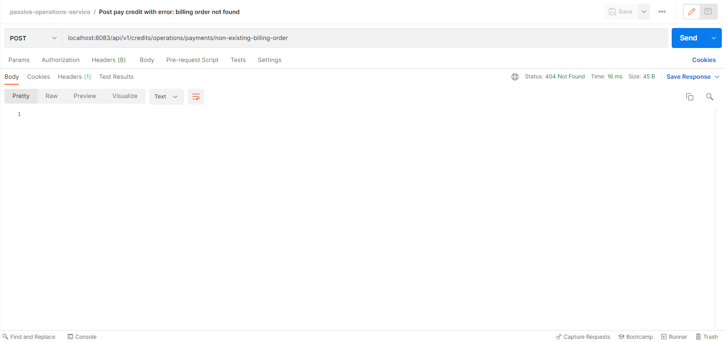

1. Get operations by credit id:

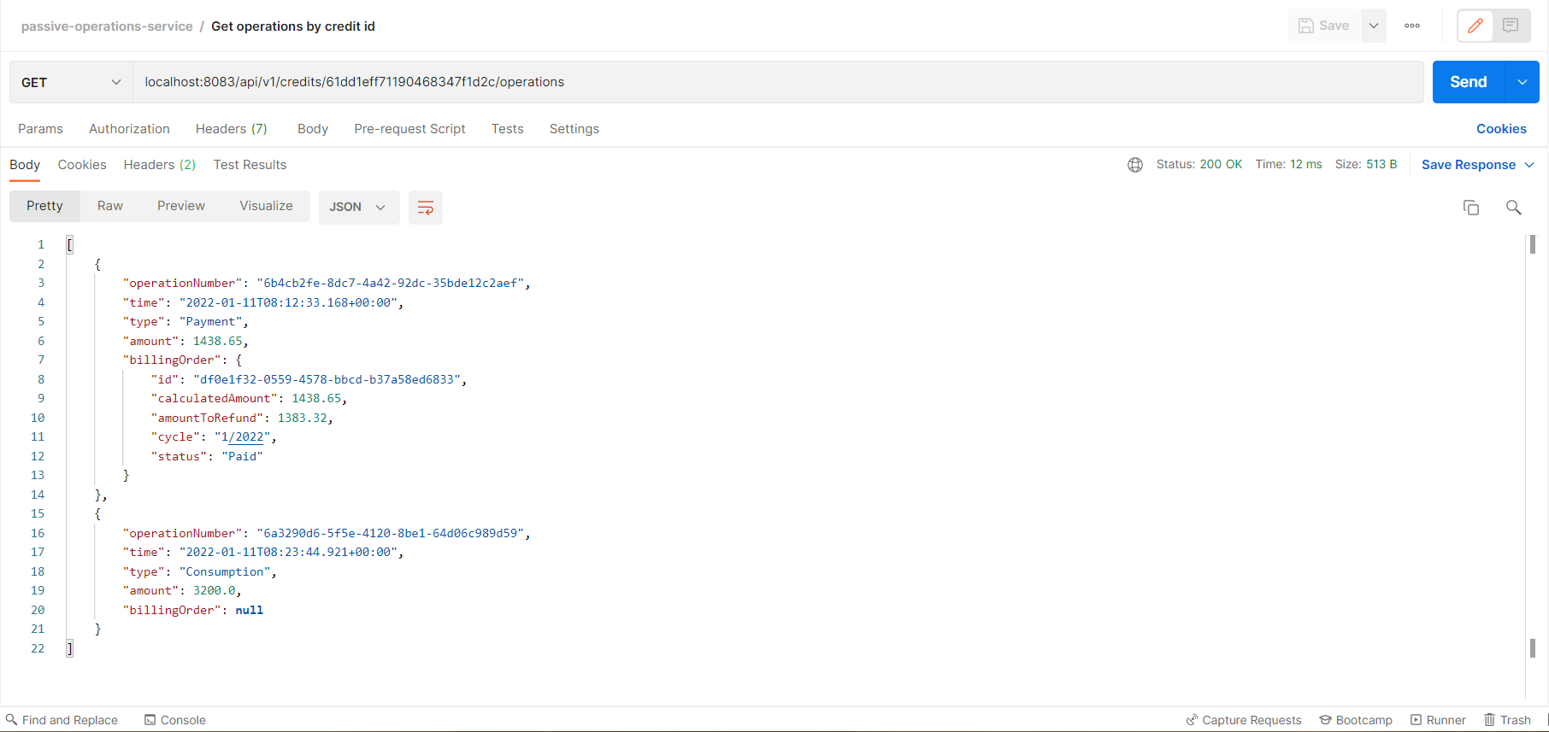

1. Get balances by customer id:

